<https://jalammar.github.io/illustrated-transformer/>

# The Illustrated Transformer

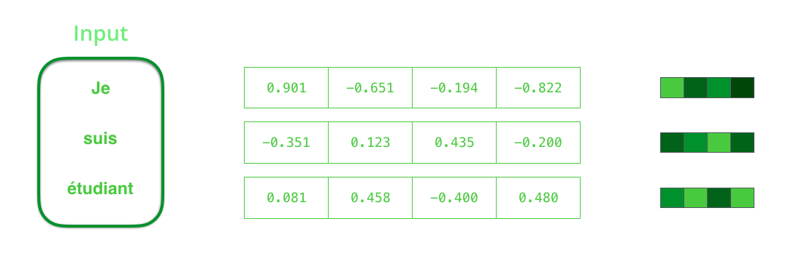

**The Transformer** – a model that uses attention to boost the speed with which these models can be trained. The Transformer outperforms the Google Neural Machine Translation model in specific tasks.

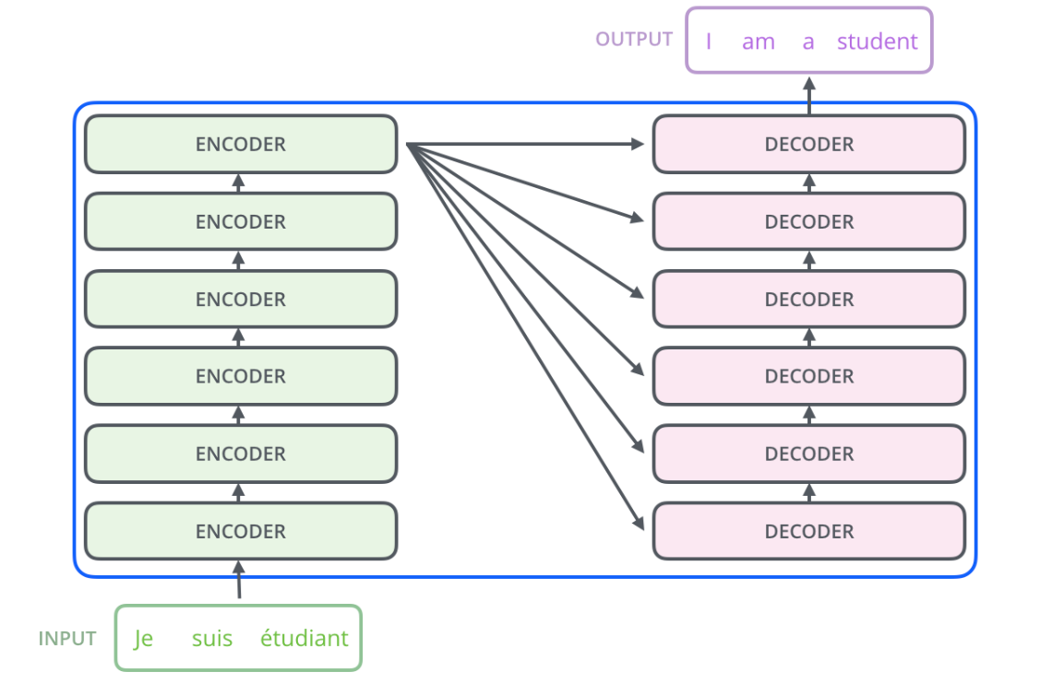

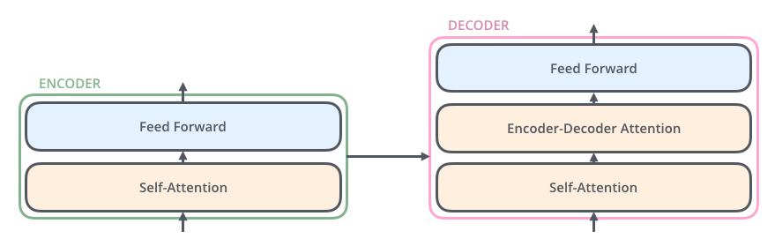

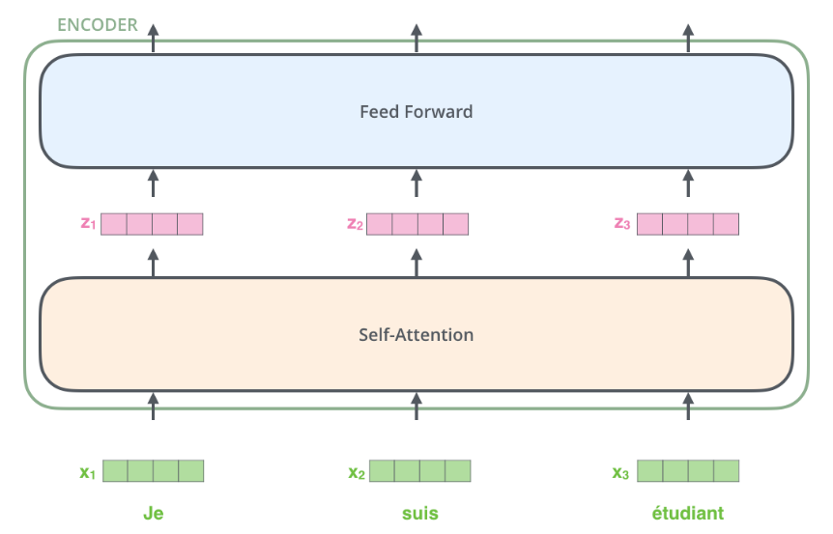

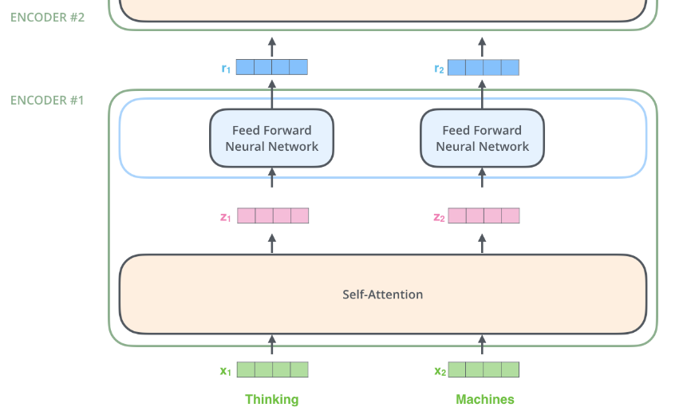

The word at each position passes through a self-attention process. Then, they each pass through a feed-forward neural network -- the exact same network with each vector flowing through it separately.

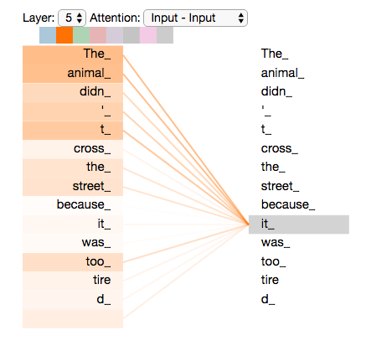

## Self-Attention in Detail

The **first step** in calculating self-attention is to create three vectors from each of the encoder’s input vectors (in this case, the embedding of each word). So for each word, we create a Query vector, a Key vector, and a Value vector. These vectors are created by multiplying the embedding by three matrices that we trained during the training process.

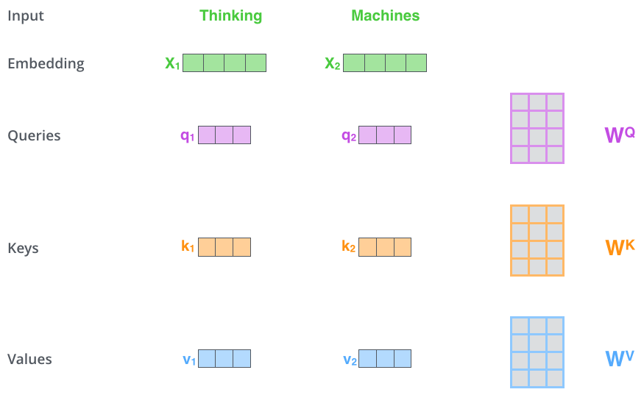

The **second step** in calculating self-attention is to calculate a score. Say we’re calculating the self-attention for the first word in this example, “Thinking”. We need to score each word of the input sentence against this word. The score determines how much focus to place on other parts of the input sentence as we encode a word at a certain position.

The score is calculated by taking the dot product of the query vector with the key vector of the respective word we’re scoring. So if we’re processing the self-attention for the word in position #1, the first score would be the dot product of q1 and k1. The second score would be the dot product of q1 and k2.

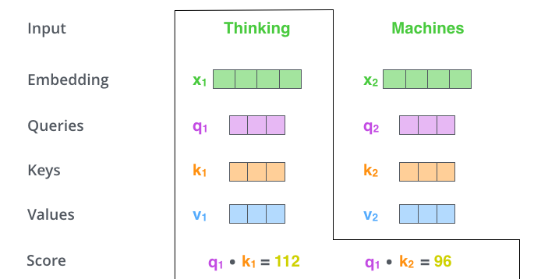

The **third and fourth steps** are to divide the scores by 8 (the square root of the dimension of the key vectors used in the paper – 64. This leads to having more stable gradients. There could be other possible values here, but this is the default), then pass the result through a softmax operation. Softmax normalizes the scores so they’re all positive and add up to 1.

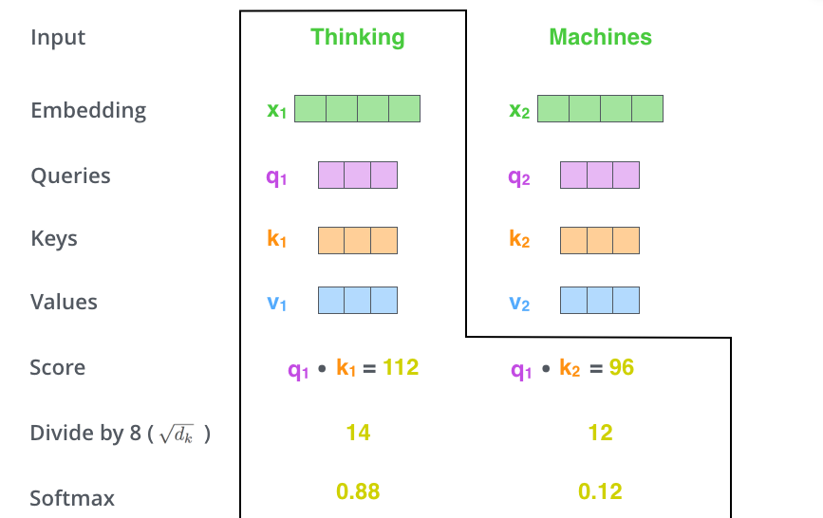

The **fifth step** is to multiply each value vector by the softmax score (in preparation to sum them up). The intuition here is to keep intact the values of the word(s) we want to focus on, and drown-out irrelevant words (by multiplying them by tiny numbers like 0.001, for example).

The **sixth step** is to sum up the weighted value vectors. This produces the output of the self-attention layer at this position (for the first word).

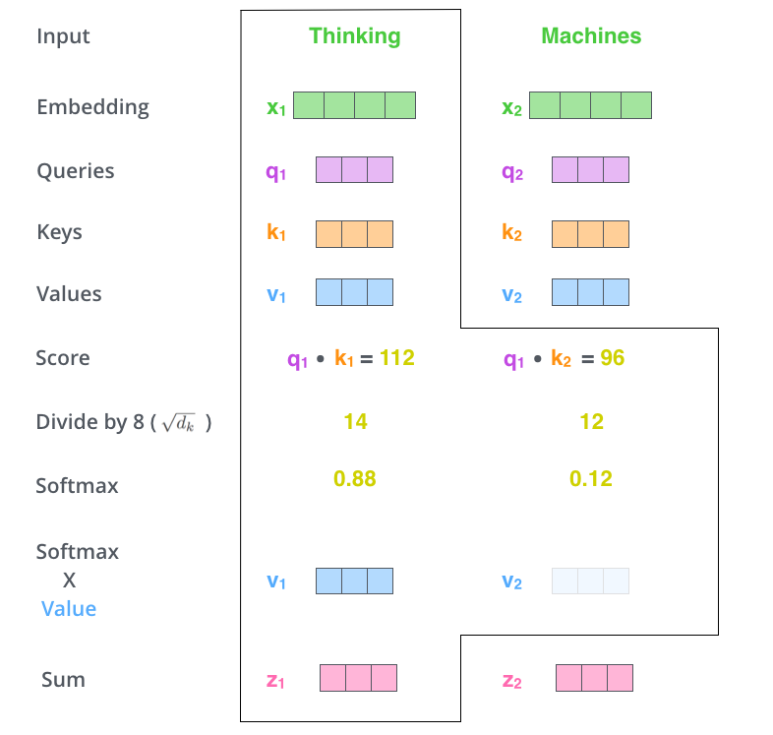

## Matrix Calculation of Self-Attention

**The first step** is to calculate the Query, Key, and Value matrices. We do that by packing our embeddings into a matrix X, and multiplying it by the weight matrices we’ve trained (WQ, WK, WV).

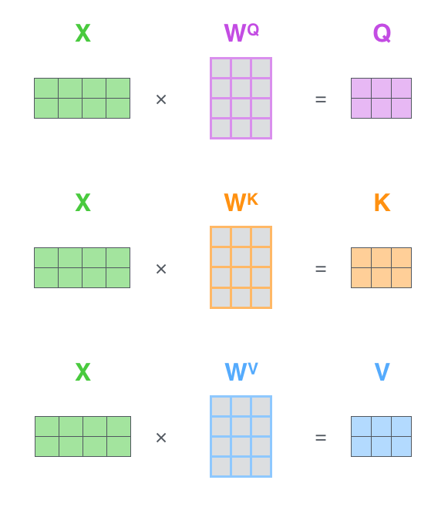

**Finally**, since we’re dealing with matrices, we can condense steps two through six in one formula to calculate the outputs of the self-attention layer.

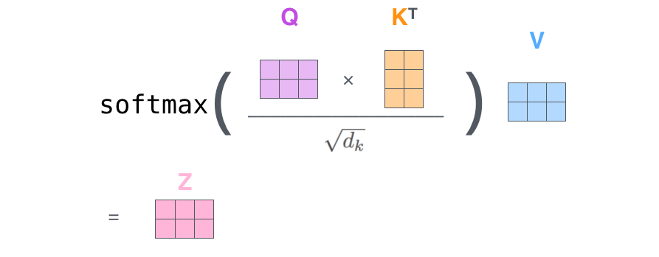

## The Decoder Side



## The Final Linear and Softmax Layer

The decoder stack outputs a vector of floats. How do we turn that into a word? That’s the job of the final Linear layer which is followed by a Softmax Layer.

The Linear layer is a simple fully connected neural network that projects the vector produced by the stack of decoders, into a much, much larger vector called a logits vector.

Let’s assume that our model knows 10,000 unique English words (our model’s “output vocabulary”) that it’s learned from its training dataset. This would make the logits vector 10,000 cells wide – each cell corresponding to the score of a unique word. That is how we interpret the output of the model followed by the Linear layer.

The softmax layer then turns those scores into probabilities (all positive, all add up to 1.0). The cell with the highest probability is chosen, and the word associated with it is produced as the output for this time step.

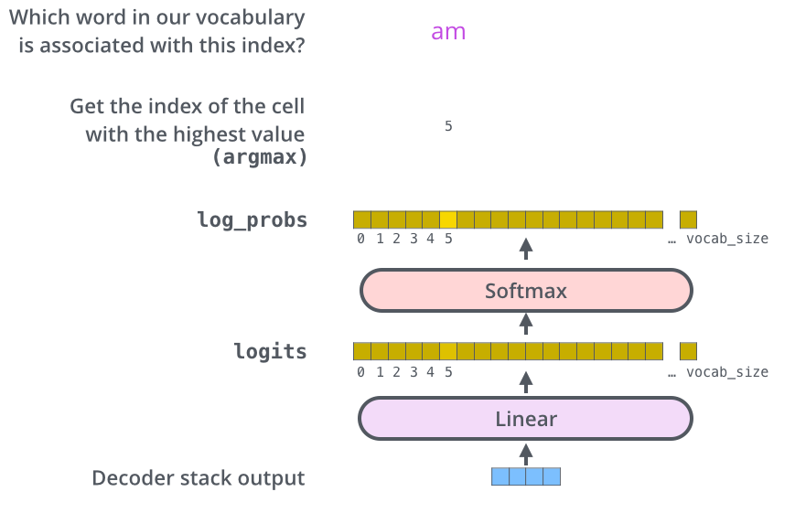

## The Loss Function

How do you compare two probability distributions? We simply subtract one from the other. For more details, look at [cross-entropy](https://colah.github.io/posts/2015-09-Visual-Information/) and [Kullback–Leibler divergence](https://www.countbayesie.com/blog/2017/5/9/kullback-leibler-divergence-explained).

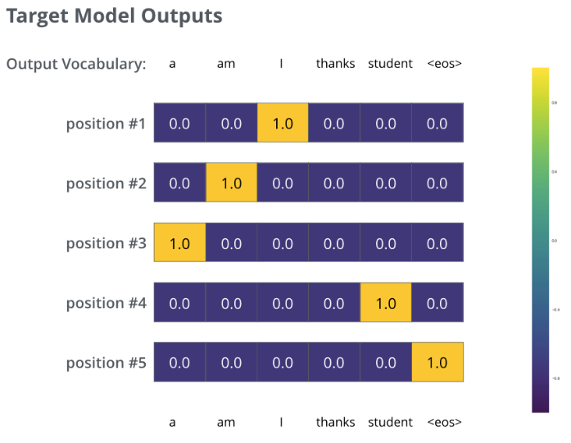

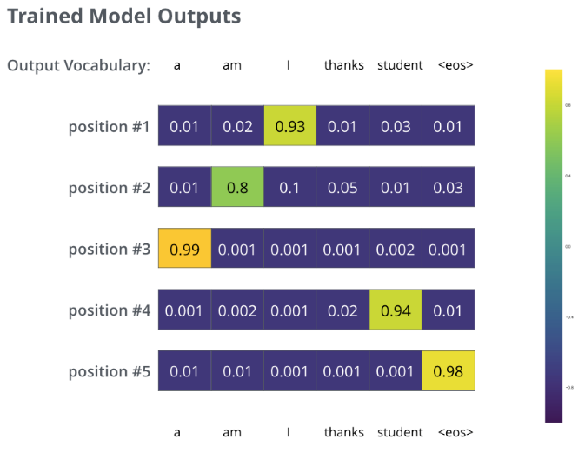

<https://towardsdatascience.com/bert-for-dummies-step-by-step-tutorial-fb90890ffe03>

# BERT for dummies — Step by Step Tutorial

One type of network built with attention is called a **Transformer.**Itapplies attention mechanisms to gather information about the relevant context of a given word, and then encode that context in a rich vector that smartly represents the word.

[BERT: Pre-training of Deep Bidirectional Transformers](https://arxiv.org/abs/1810.04805), a novel Transformer-approach, pre-trained on large corpora and open-sourced.

SMOTE uses a k-Nearest Neighbors classifier to create synthetic datapoints as a multi-dimensional interpolation of closely related groups of true data points.

## **What is BERT?**

BERT is basically a trained Transformer Encoder stack, with twelve in the Base version, and twenty-four in the Large version, compared to 6 encoder layers in the original Transformer

BERT encoders have larger feedforward networks (768 and 1024 nodes in Base and Large respectively) and more attention heads (12 and 16 respectively).

BERT works similarly to the Transformer encoder stack, by taking a sequence of words as input which keep flowing up the stack from one encoder to the next, while new sequences are coming in.

BERT expects input data in a specific format, with **special tokens** to mark the beginning ([CLS]) and separation/end of sentences ([SEP]). Furthermore, we need to **tokenize**our text into tokens that correspond to BERT’s vocabulary.

### Interquartile Range (IQR) :

The IQR is a measure of the distance between the 1st quartile (Q1) and 3rd quartile (Q3).

### Skewness:

Skewness measures the shape of the distribution. A distribution is symmetrical when the proportion of data at an equal distance from the mean (or median) is equal. If the values extend to the right, it is right-skewed, and if the values extend left, it is left-skewed.

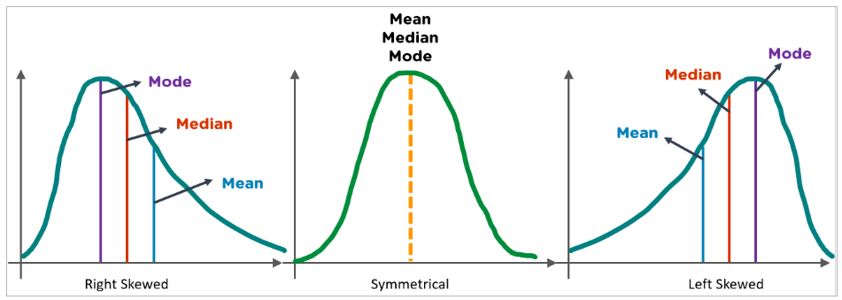

### Kurtosis:

Kurtosis in statistics is used to check whether the tails of a given distribution have extreme values. It also represents the shape of a probability distribution.

## **Gaussian Distribution**

In statistics and probability, Gaussian (normal) distribution is a popular continuous probability distribution for any random variable. It is characterized by 2 parameters (mean μ and standard deviation σ). Many natural phenomena follow a normal distribution, such as the heights of people and IQ scores.

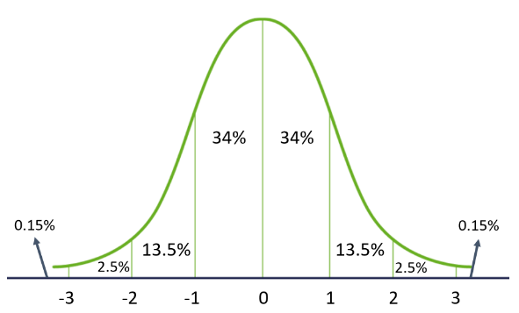

Properties of Gaussian Distribution:

* The mean, median, and mode are the same
* It has a symmetrical bell shape
* 68% data lies within 1 standard deviation of the mean
* 95% data lie within 2 standard deviations of the mean
* 99.7% of the data lie within 3 standard deviations of the mean

## **Hypothesis Testing**

Hypothesis testing is a statistical analysis to make decisions using experimental data. It allows you to statistically back up some findings you have made in looking at the data. In hypothesis testing, you make a claim and the claim is usually about population parameters such as mean, median, standard deviation, etc.

* The assumption made for a statistical test is called the null hypothesis (H0).
* The Alternative hypothesis (H1) contradicts the null hypothesis stating that the assumptions do not hold true at some level of significance.

Hypothesis testing lets you decide to either reject or retain a null hypothesis.

Example: H0: The average BMI of boys and girls in a class is the same

    H1: The average BMI of boys and girls in a class is not the same

To determine whether a finding is statistically significant, you need to interpret the p-value. It is common to compare the p-value to a threshold value called the significance level.

It often sets the level of significance to 5% or 0.05.

If the p-value > 0.05 - Accept the null hypothesis.

If the p-value < 0.05 - Reject the null hypothesis.

Some popular hypothesis tests are:

* Chi-square test
* T-test
* Z-test
* Analysis of Variance (ANOVA)

<https://statisticsbyjim.com/anova/f-tests-anova/>

# **How F-tests work in Analysis of Variance (ANOVA)**

## **Introducing F-tests and F-statistics!**

The term F-test is based on the fact that these tests use the F-values to test the hypotheses. An F-statistic is the ratio of two variances and it was named after Sir Ronald Fisher. [Variances](https://statisticsbyjim.com/basics/variance/) measure the dispersal of the data points around the mean. Higher variances occur when the individual data points tend to fall further from the mean

An F-value is the ratio of two variances, or technically, two mean squares. Mean squares are simply variances that account for the degrees of freedom (DF) used to [estimate](https://statisticsbyjim.com/glossary/estimator/) the variance. F-values are the test statistic for F-tests. Learn more about [Test Statistics](https://statisticsbyjim.com/hypothesis-testing/test-statistic/).

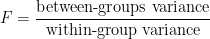

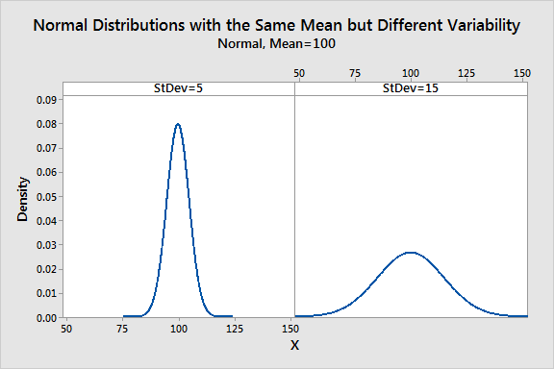

I’ve divided the dataset below into quartiles. The interquartile range (IQR) extends from the low end of Q2 to the upper limit of Q3. For this dataset, the range is 39 – 20 = 19.

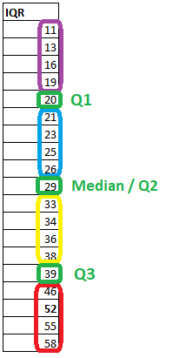

The calculation for a p-value varies based on the type of test performed. The three test types describe the location on the probability distribution curve: lower-tailed test, upper-tailed test, or [two-tailed test](https://www.investopedia.com/terms/t/two-tailed-test.asp).

 The smaller the p-value, the greater the evidence against the null hypothesis.

## **Is a 0.05 p-value significant?**

A p-value less than 0.05 is typically considered to be statistically significant, in which case the null hypothesis should be rejected. A p-value greater than 0.05 means that deviation from the null hypothesis is not statistically significant, and the null hypothesis is not rejected.

## **What does a p-value of 0.001 mean?**

A p-value of 0.001 indicates that if the null hypothesis tested were indeed true, then there would be a one-in-1,000 chance of observing results at least as extreme. This leads the observer to reject the null hypothesis because either a highly rare data result has been observed or the null hypothesis is incorrect.

# Steps Involved in the PCA

**Step 1:** Standardize the dataset.

**Step 2:**Calculate the covariance matrix for the features in the dataset.

**Step 3:**Calculate the eigenvalues and eigenvectors for the covariance matrix.

**Step 4:**Sort eigenvalues and their corresponding eigenvectors.

**Step 5:**Pick k eigenvalues and form a matrix of eigenvectors.

**Step 6:** Transform the original matrix.

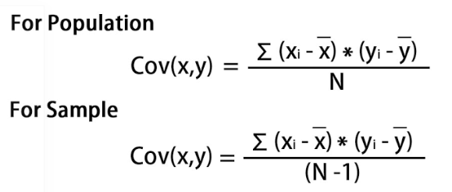

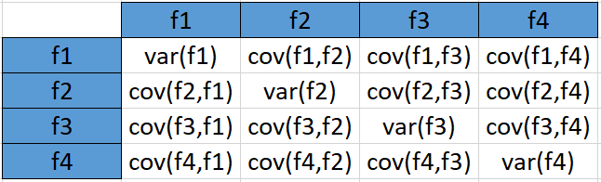

An **eigenvector** is a nonzero vector that changes at most by a scalar factor when that linear transformation is applied to it. The corresponding **eigenvalue** is the factor by which the eigenvector is scaled.

Let A be a square matrix (in our case the covariance matrix), ν a vector and λ a scalar that satisfies Aν = λν, then λ is called eigenvalue associated with eigenvector ν of A.  
Rearranging the above equation,

Aν-λν =0 ; (A-λI)ν = 0

## 4. **Sort eigenvalues and their corresponding eigenvectors.**

Since eigenvalues are already sorted in this case so no need to sort them again.

## 5. Pick k eigenvalues and form a matrix of eigenvectors

If we choose the top 2 eigenvectors, the matrix will look like this:

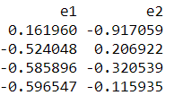

## **6.** Transform the original matrix.

Feature matrix * top k eigenvectors = Transformed Data

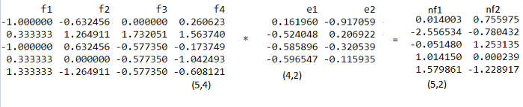

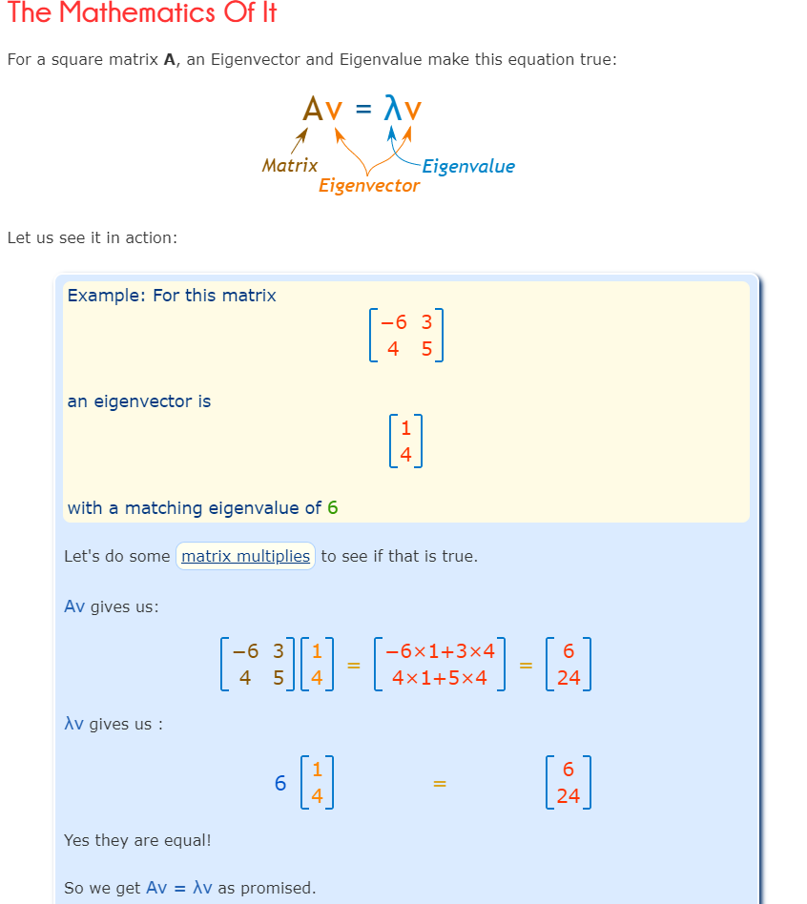––

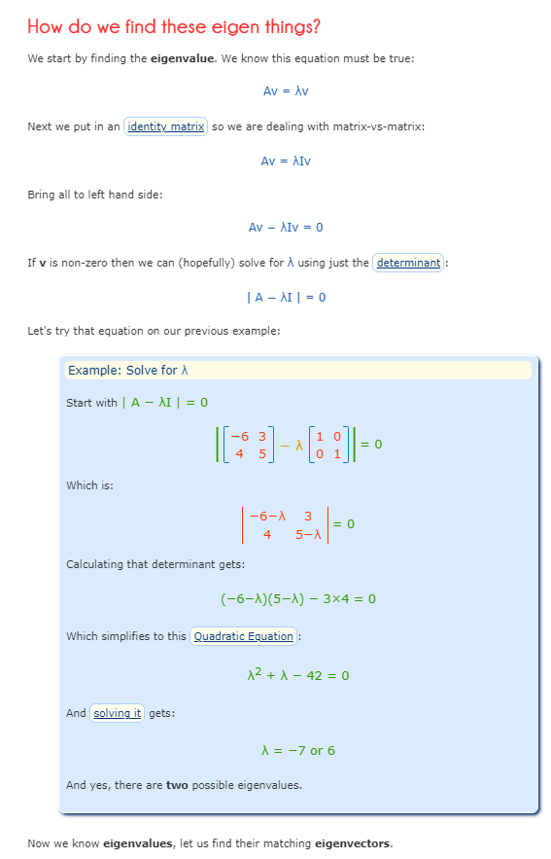

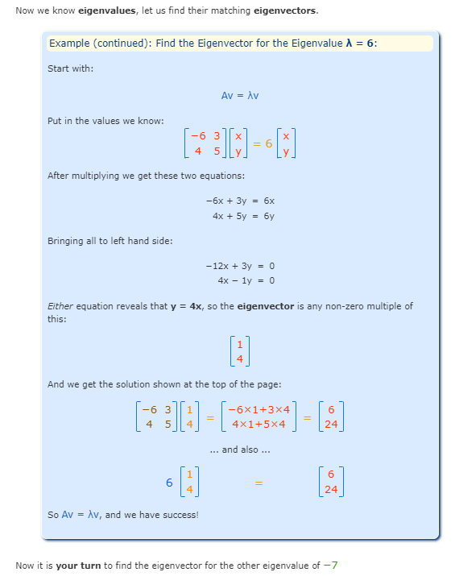

## Why?

What is the purpose of these?

One of the cool things is we can use [matrices](https://www.mathsisfun.com/algebra/matrix-introduction.html) to do [transformations](https://www.mathsisfun.com/algebra/matrix-transform.html) in space, which is used a lot in computer graphics.

In that case the eigenvector is "the direction that doesn't change direction" !

And the eigenvalue is the scale of the stretch:

* **1** means no change,
* **2** means doubling in length,
* **−1** means pointing backwards along the eigenvalue's direction
* etc

There are also many applications in physics, etc.

<https://www.analyticsvidhya.com/blog/2021/09/latent-semantic-analysis-and-its-uses-in-natural-language-processing/>

# Latent Semantic Analysis and its Uses in Natural Language Processing

Latent Semantic Analysis (LSA) involves creating structured data from a collection of unstructured texts.

Rather, we think about a theme (or topic) and then chose words such that we can express our thoughts to others in a more meaningful way. This theme or topic is usually considered as a latent dimension.

## **What is Singular Value Decomposition (SVD)?**

[Singular Value Decomposition or SVD](https://www.analyticsvidhya.com/blog/2019/08/5-applications-singular-value-decomposition-svd-data-science/) is essentially a matrix factorization technique. In this method, any matrix can be decomposed into three parts as shown below.

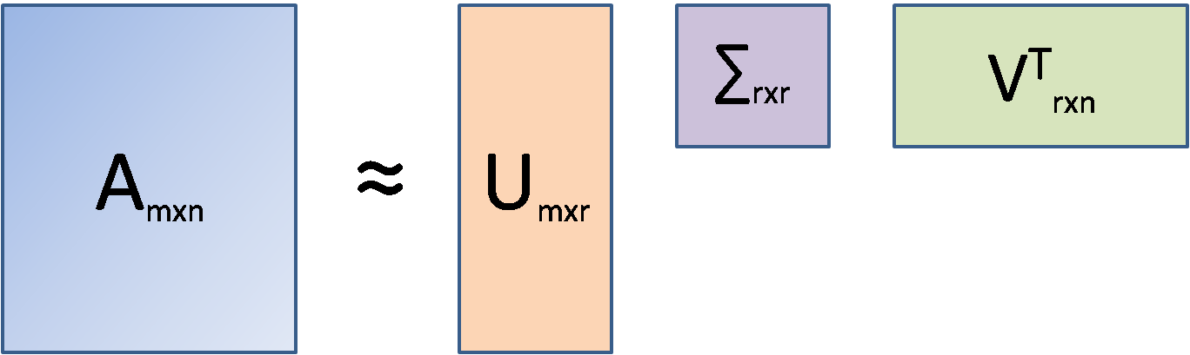

Here, A is the document-term matrix (documents in the rows(m), unique words in the columns(n), and frequencies at the intersections of documents and words). It is to be kept in mind that in LSA, the original document-term matrix is approximated by way of multiplying three other matrices, i.e., U, ∑ and VT. Here, r is the number of aspects or topics. Once we fix r (r<<n) and run SVD, the outcome that comes out is called Truncated SVD and LSA is essentially a truncated SVD only.

SVD is used in such situations because, unlike PCA, SVD does not require a correlation matrix or a covariance matrix to decompose. In that sense, SVD is free from any normality assumption of data (covariance calculation assumes a normal distribution of data).

The U matrix is the document-aspect matrix, V is the word-aspect matrix, and ∑ is the diagonal matrix of the singular values. Similar to PCA, SVD also combines columns of the original matrix linearly to arrive at the U matrix.

Using LSA, a low-rank approximation of the original matrix can be created (with some loss of information although!) that can be used for our clustering purpose.

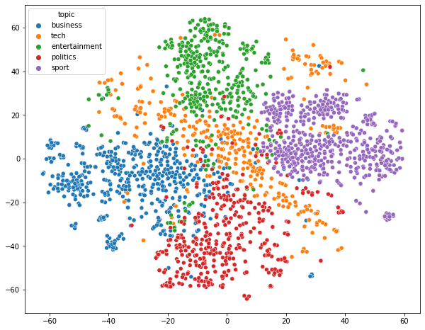

<https://mlops.community/the-what-why-and-how-of-a-b-testing-in-ml/#:~:text=A%2FB%20testing%20lets%20organizations,better%20in%20the%20real%20world>.

An [A/B test](https://en.wikipedia.org/wiki/A/B_testing), also called a controlled experiment or a randomized control trial, is a statistical  
method of determining which of a set of variants is the best. A/B tests allow organizations  
and policy-makers to make smarter, data-driven decisions that are less dependent on  
guesswork.

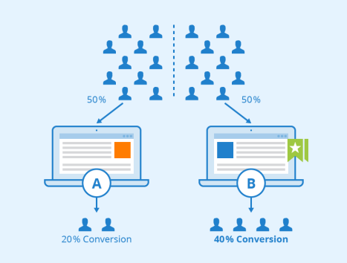

## **Designing a Machine Learning A/B Test**

A/B tests are a useful way to rely less on opinions and intuition and to be more data-driven in decision-making, but there are a few principles to keep in mind. The experimenter has to decide on a number of things.

**First, decide what you are trying to measure.**We’ll call this the Overall Evaluation Criterion or OEC. This may be different and more business-focused than the loss function used while training the models, but it must be something you can measure. Common examples are revenue, click-thru rate, conversion rate, or process completion rate.   
  
**Second, decide how much better is “better”.**You might want to just say “Success is when the challenger is better than the champion,” but that’s actually not a testable question, at least not in the statistical sense. You have to decide how much better the challenger has to be. Let’s define two quantities:

● ***y0****:*The champion’s assumed OEC. Since the champion has been running for a while, we should have a good idea of this value. For example, if we are measuring conversion rate, then we might already know that the champion typically achieves a conversion rate of *y0=*2%.

● **δ**: the *minimum delta effect size*we want to reliably detect. This is how much better the challenger needs to be for us to declare it “the winner.” For example, we may decide to switch to our challenger model if it improves the conversion rate by at least 1% – that is, we want the challenger to have a conversion rate of at least 0.02 * (1.01) = 0.0202. This means **δ** = 0.002.  
  
Note that some sample size calculators (we’ll get to that below) specify minimum effect size as a relative delta; in our example, the relative delta is 0.01 (1%), and the absolute delta is 0.002.

**Third, decide how much error you want to tolerate**. Again, you probably want to say “none,” but that isn’t practical. The less error you can tolerate, the more data you need, and in an online setting, the longer you have to run the test. In the classical statistics formulation, an A/B test has the following parameters to describe the error:

● ***n* :**the minimum number of examples (per model) we have to examine to make sure our false positive rate **α** and true positive rate **β** thresholds are met. Or as it’s commonly said: “to make sure we achieve statistical significance.”

Note that n is per model: so if you are routing your customers between A and B with a 50-50 split, you need a total experiment size of 2*n customers. If you are routing 90% of your traffic to A and 10% to B, then B has to see at least n customers (and A will then see around 9*n). So a 50-50 split is the most efficient, although you may prefer an unbalanced split for other reasons, like safety or stability.

## **Some Practical Considerations**

**Splitting your subjects:**When splitting your subjects up randomly between models, make sure the process is truly random, and think through any interference between the two groups. Do they communicate or influence each other in some way? Does the randomization method cause an unintended bias? Any bias in group assignments can invalidate the results. Also, make sure the assignment is consistent so that each subject always gets the same treatment. For example, a specific customer should not get different prices every time they reload the pricing page.

**A/A Tests:**It can be a good idea to run an A/A test, where both groups are control or treatment groups. This can help surface unintentional biases or errors in the processing and can give a better feeling for how random variations can affect intermediate results.

**Don’t Peek!:**Due to human nature, it’s difficult not to peek at the results early and draw conclusions or stop the experiment before the minimum sample size is reached. Resist the temptation. Sometimes the “wrong” model can get lucky for a while. You want to run a test long enough to be confident that the behavior you see is really representative and not just a weird fluke.   
  
**The more sensitive a test is, the longer it will take:**The resolution of an A/B test (how small a delta effect size you can detect) increases as the square of the samples. In other words, if you want to halve the delta effect size you can detect, you have to quadruple your sample size.

<https://neptune.ai/blog/model-debugging-strategies-machine-learning>

# Model Debugging Strategies: Machine Learning Guide

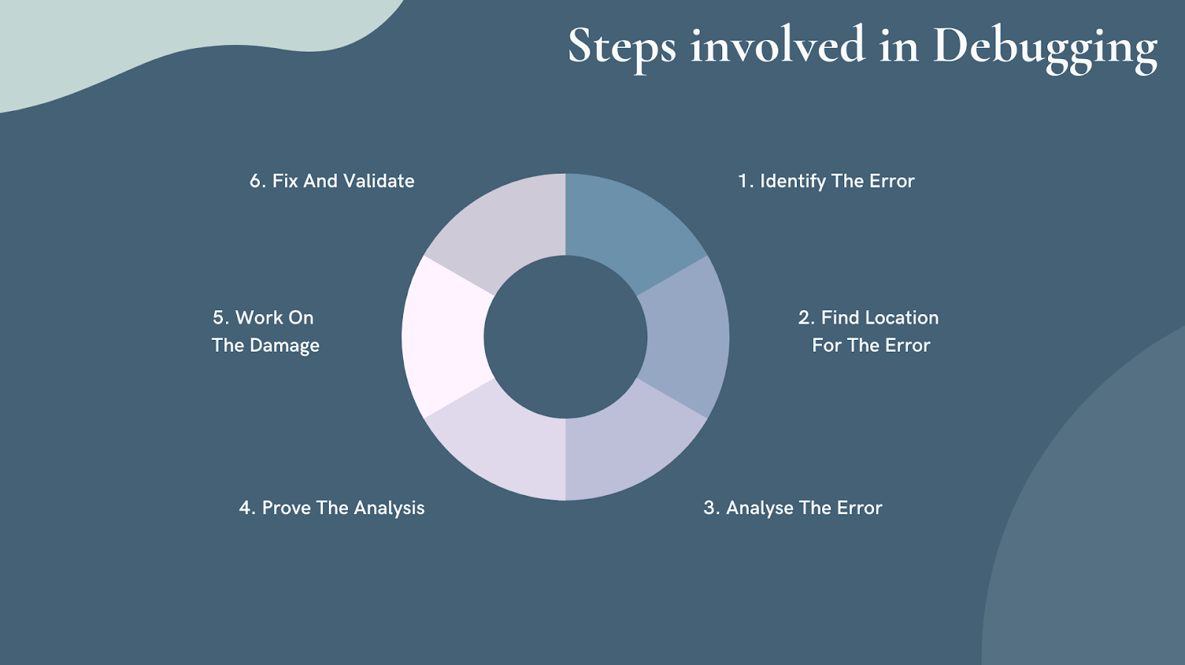

1. **Identify the Error:** To fix the issue, you need to know that you have an issue in the first place. There are plenty of ways to identify errors, like performance monitoring and user feedback.
2. **Locate the Error:** It’s time to see where exactly the error is happening. Inspect the system thoroughly to find it.
3. **Analyze the Error:** Analyze the code to identify more issues and estimate the risk that the error creates.
4. **Prove the Analysis:** Work with automated tests, after analyzing the bug you might find a few more errors in the application.
5. **Work On the Damage:** Collect all test units for the program where you’ll be making changes. Now you can run test units and monitor their performance.
6. **Fix and Validate:**Fix the issue, run all test units, monitor performance.

**Common bugs in machine learning models**

* **Dimension error**

The most common issue in models is the dimension, which happens because of the nature of linear algebra. Most popular libraries can spot inconsistent shapes. **While working with matrices, let’s say we use shape(n1,n2)(n3,n4) so in matrix multiplication, it is important to match n1 and n3 dimensions for the matmul to work. It’s also critical to find where they’re coming from.**

If you want a model summary like Tensorflow for Keras in PyTorch, just use:

!pip install torchsummary

It’ll display results in the table format for each layer.

* **Variable**

Data goes through a long process starting from preparation, cleaning, and more. In this process, developers often get confused or forget correct data variables. So, to stay on the correct path, it’s good practice to **use a data flow diagram before architecting our models**. This will help us find the correct data variable names, model flow, and expected results.

* **Flaws in input data**

To figure out if our model contains predictive information or not, try with humans first. If humans can’t predict the data (image or text), then our ML model won’t make any difference. If we try to feed it more inputs, it still won’t make a difference. Chances are that the model will lose its accuracy.

Once we get adequate predictive information, we need to know if our data is adequate to train a model and get the signal. In general, we need a minimum of 30 samples per class and 10 samples for specific features.

***Size Of Dataset ∝ Number Of Parameters In Model***

*The exact shape of the above equation depends on your machine learning application.*

* **Learn from minimal data**

When you work on machine learning projects, you might not have enough data. A good method to solve this is to augment your data. You can generate new data with generative models and generative adversarial networks, such as autoencoders. Autoencoders help to learn structured data codings in an unsupervised manner.

External data, let’s say data found on the internet or open-sourced, can be useful. Once you collect that data and label it, you can then use it for training. It can also be used for many other tasks. Just like external data, we can also use an external model which was trained by another person and reuse it for our task.

Using a high-quality but small dataset is the best way to train a simple model**.** Sometimes, when you use large training data sets you can waste too many resources and money.

* **Preparing data and avoiding the common issue**

When preparing features, it’s crucial to measure the scaling factors, mean, and standard deviation on the test dataset. Measuring these will improve the performance on the test data set. Standardization will help you make sure that all data has an SD of 1 and a mean of 0. This is more effective if the data has outliers, and it’s the most effective way to scale a feature.

* **Hyperparameter Tuning**

Hyperparameter tuning is about improving the hyperparameters. These parameters control the behavior of a learning algorithm. For example, learning rate (alpha), or the complexity parameter (m) in gradient descent optimization.

A common hyperparameter tuning case is to select optimal values by using cross-validation in order to choose what works best on unseen data. This evaluates how model parameters get updated during the training period. Often this task is carried out manually, using a simple trial and error method. There are plenty of different ways to tune hyperparameters, such as grid searches, random search methods, Bayesian optimization methods, and a simple educated guess.

* **Logging**

Logging is a way of monitoring any issue, but it’s best not to log useless information. Sometimes it’s very important to comment/log all the decisions and information that is exchanged. This might be difficult, but it should be possible to map out all possible scenarios and put logging to solve that.

The important details are, for example, values from arguments, runtimes types from classes, software decisions, and more. This depends on the type of your issue.

## Most-used model debugging strategies

### Sensitivity analysis

Sensitivity analysis is a statistical technique that estimates how sensitive a model, parameter, or other quantity is to changes in the input parameters from their nominal values. This analysis shows how a model reacts to unseen data, and what it predicts from given data. Developers often refer to it as the “What if” analysis.

Suppose we have a model that predicts housing prices will rise by 10% given a 10% rise in a specific area. To see if this is true, we simulate data where the population increases by 10%. If predictions are correct and housing prices increase by 10%, it’s done. However, if the prediction is off, for example, the predicted value of housing doesn’t change, then the model is sensitive to changes in one or more of its input variables. With sensitivity analysis, we can figure out which input variable(s) are causing the problem. What if the prices increase by 10%, 20%, or 50%? It will help us demonstrate that prices are sensitive to changes in buyer traffic.

The example above is a prediction of an unknown quantity (housing prices). For models that make predictions about known quantities (e.g. the stock market), sensitivity analysis is even more important. The [What-if-tool](https://pair-code.github.io/what-if-tool/index.html#about) is the best way to visually monitor the behavior of trained ML models, with minimal coding.

Sensitivity analysis will help us study all the variables in depth. Because of this, predictions become more trustworthy. It also helps developers to recognize what could be improved in the future.

### Residual analysis

The most used method among data scientists and developers. It’s a numeric evaluation of model errors and the difference between observed and predicted outcomes. Residual plots are very helpful in determining where a model is wrong (misclassifying data points). In simple terms, residuals can be calculated by subtracting predicted values from observed values.

1. 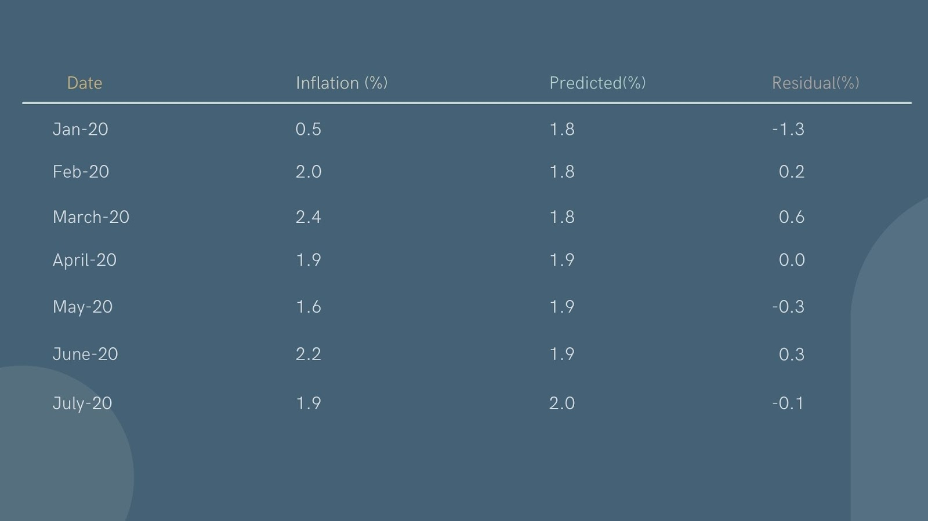**Quantile Plots**: The quantile plot is a graphical representation to see if the distribution of residuals is standard or not. It’s a plot of the quantiles of the actual and normal distribution. If the graph is overlapping on a diagonal, then it’s normally distributed. It helps us to test many distributional aspects.

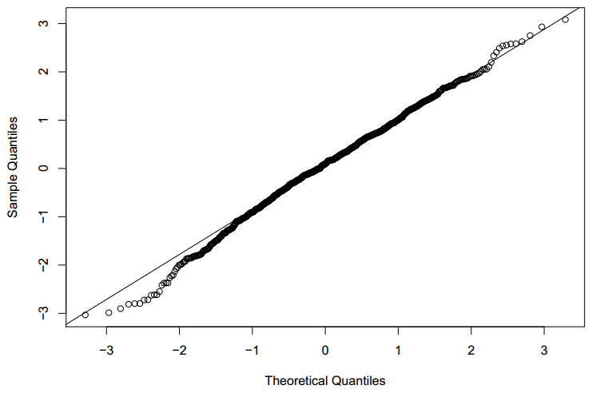

1. **Scatter Plots**: The Scatter plot is a graphical representation to evaluate variance and linearity. The two dots depict two different values. They can help us visualize how two or more variables relate to each other. It’s often an effective way to analyze data and evaluate the relationship between two or more items. Another advantage is that building a scatter plot requires minimal math skills and provides a good sense of understanding about what we’re seeing in the data.

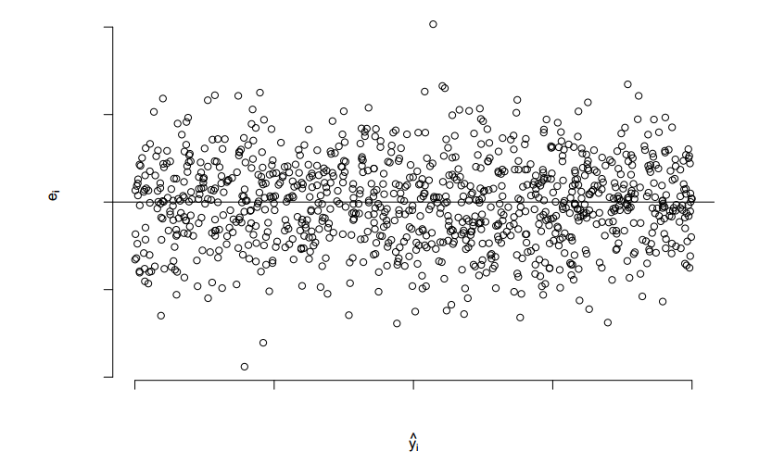

Created by author with [Canva](https://www.canva.com/)

Residuals = Observed Values (Inflation for above image) – Predicted values

### Benchmark models

A Benchmark Model is the most easy-to-use, reliable, transparent, and interpretable model that you can compare your model with. It’s best practice to check if your new machine learning model performs better than a known benchmark in test datasets.

A Benchmark model is easy to implement and doesn’t take much time. Use any standard algorithm to find a suitable benchmark model, and then just compare the results with model predictions. If there are many common features between standard algorithms and ML algorithms, a simple regression might already reveal possible problems with the algorithm.

Additionally, benchmark models can be used to estimate how our ML model will perform on different data classes. For example, if we’re surprised that our ML model is overfitting on some data, a benchmark model can help us understand whether it’s because the data is special or not.

### Security audits

There are many attacks against machine learning models which can impact the model results and datasets. Commonly used assessment practices don’t tell us if a model is safe or not.

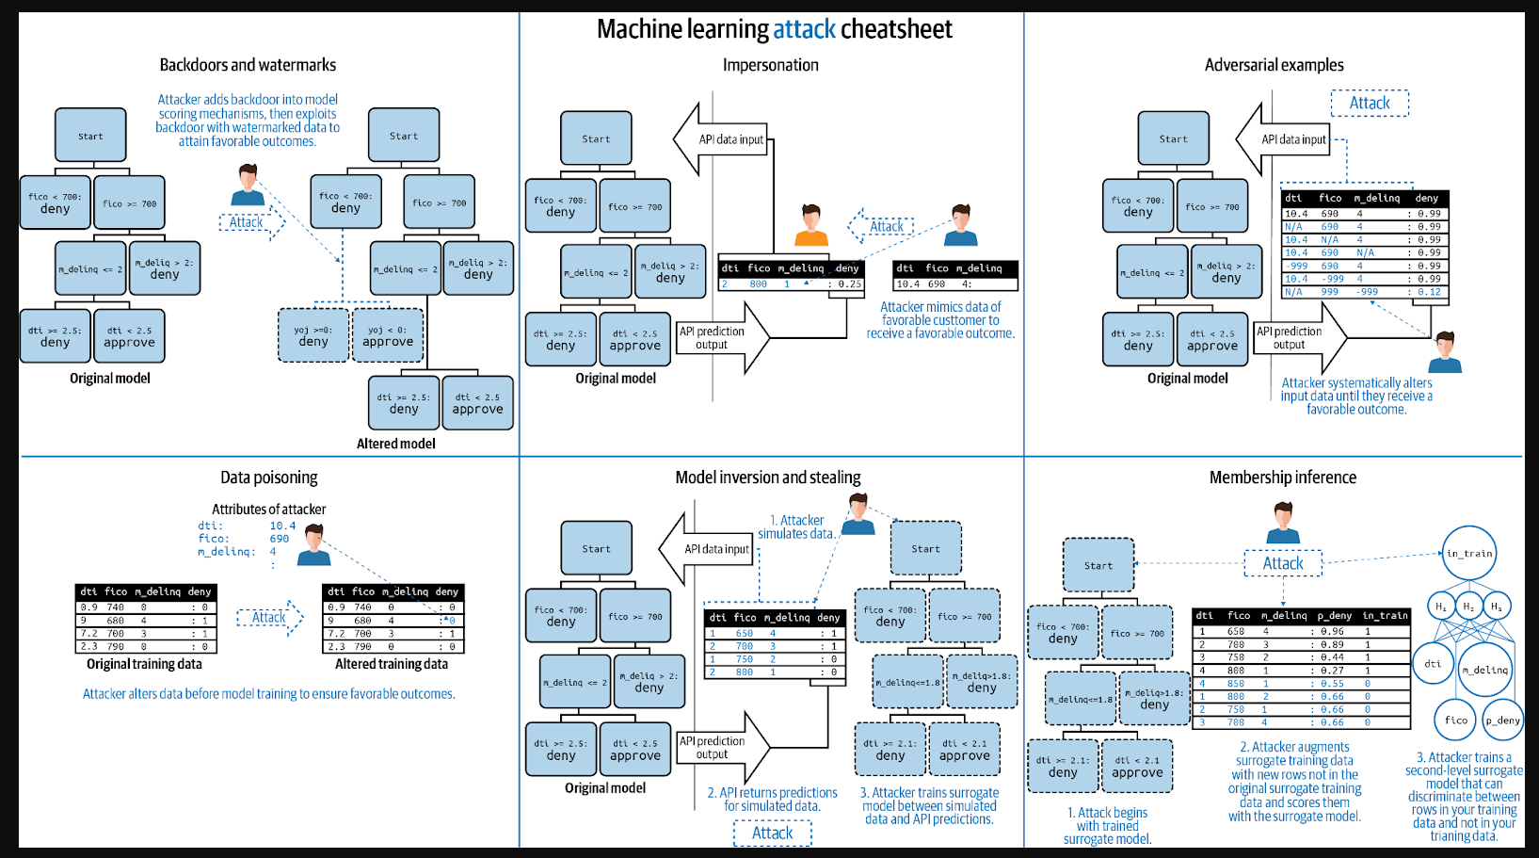

**Data augmentation**

Data augmentation is a machine learning technique that can help us implement missing data. At its most basic definition, data augmentation is a method to add new training samples to fill in places where we have gaps in our dataset.

We can augment:

1. Audio
2. Text
3. Images
4. Any other types of data

Machine learning solutions combine a set of data with the mathematical equations that transform this available data into conclusions about the answers we want to find.

One of the most common uses for data augmentation is to fill missing data gaps within our training dataset. It’s common in ML problems to have a training dataset (and possibly a validation dataset) that doesn’t have every possible answer (or parameter of an algorithm).

But there can be many answers or parameters that may ‘predict’ correctly from the available data, which are missing from our dataset but required by the model. For example, for images, we can use

* Geometric transformations,
* Color space transformations,
* Kernel filters,
* Random Erasing,
* Mixing images.

For text, there’s word shuffling, replacement, and Syntax manipulation. For audio noise injection—shifting, speed of audio, and more.

### Model editing and monitoring

Model editing is a technique where machine learning models are designed for human users to be able to understand how they work and edit them. This is done for the models to perform well in the future, as some ML variants are designed to be interpretable by humans, like decision trees and GA2M. Chances are other models might be hard to edit, but if they’re capable of generating a readable outcome, they can be edited.

Monitoring and managing our machine learning model is an important part of the workflow. We have to keep track of who and when trained the models. We have to keep records of all the datasets, inputs, and predictions.

These things aren’t static and can change drastically over time, so it’s important to monitor our models. Let’s say our model seems to be working pretty fine — did we think about what would happen if this weren’t the case? How will we know when our models are no longer calibrated with reality?

No one likes surprises, so it’s best not to wait with monitoring and calibration. It may be that we have a new data set with new information, and we want to see how it changes our model. Or perhaps there’s a serious issue with our model that needs to be corrected. Whatever the case may be, we’ll need a way of checking whether or not we should re-optimize and calibrate.

### Anomaly detection

Anomaly detection is a powerful security measure, one that allows organizations to detect anomalous behavior as it develops. Anomalies may include anything from unusual transactions occurring in an organization’s financial network to a hacker stealing money or data from the company. It’s very similar to other methods of fraud detection, but rather than just looking for known fraudulent transactions or patterns, it also looks for anomalies and outliers in those patterns. This means that anomalies can be detected even when they haven’t been seen before.

## Ways to improve model performance

There are many ways to improve model performance but we’ll only discuss a few top-ranking methods.

**More Data**: Adding more data is the best method to improve model performance. Resampling, cleaning, and getting more data also boosts the performance. Sometimes, you can’t add more data — but you can still create more data or get data from external sources. Adding more data is the best way to boost model performance.**Feature Engineering**: Simple process of transforming raw observations into desired features with the help of statistical or machine learning techniques. It’s always a good idea to add new features to your model, as it improves flexibility and decreases the variance. When working with feature engineering, you need to make sure you have a good amount of data and a good budget. You should be able to afford this.

**Feature Selection**: Imagine your data is like a large forest of trees. Feature selection is the process of walking through this forest and deciding which trees you want to keep, based on characteristics like height, width, or color. This analogy can be applied to data that you’re analyzing, filtering, or sifting for information. In order to extract useful information from data sets, it’s important to determine which features in the dataset we want to analyze further. We may not need all of the features. We might only need one or two out of many, so it’s important we choose intelligently and discard the rest before they take up valuable processing time in our machine learning training algorithm.

**Multiple Algorithms**: The goal here is to improve performance by using multiple algorithms and aggregating their outputs. A well-known example is Google’s search engine that uses many different statistical models for its results. You might think there would be no point in using more than one model if they’re all going to produce similar answers, but it turns out that there are some surprising benefits to doing so — even on a single day’s worth of data.

**Algorithms Tuning**: Model development is a process of trial and error. One of the most important parts of this process is tuning your algorithms to find the ones that are best for you. Tuning algorithms takes a good amount of time, it can take weeks or months to spot a good-performing algorithm. In the end, it’s worth all the time and effort you put into it.

**Ensembles**: The most used and most effective method. It combines prediction data of weak models and produces better outcomes. There are many ways to do this method. You can create multiple models with the same or different algorithms, or you can generate multiple subsamples for the training data and combine predictions to get better-performing algorithms.

**Cross-Validation**: The term cross-validation is used to describe the process of taking an algorithm and applying it to test data that hasn’t been used in training the algorithm. In machine learning, this typically means taking an unlearned model and running it on a validation set of data, which is then compared with the original training set. Cross-validation can be done using “leave-one-out” or repeated cross-validation schemes.

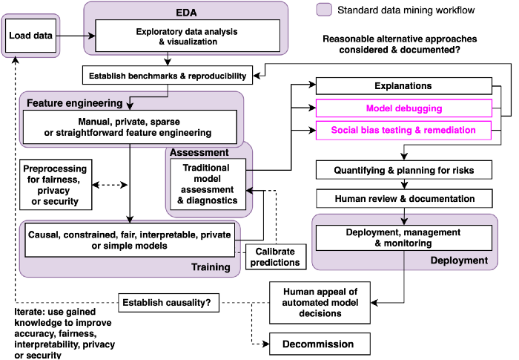

<https://towardsdatascience.com/strategies-for-model-debugging-aa822f1097ce>

## 2.1.3 Random attacks

## 2.2 Residual Analysis

## 3.2 Noise Injection and Strong Regularization

## 3.3 Model Editing

## 3.6 Model Management and Monitoring

## 3.7 Anomaly Detection

# [**Is it better to pre-filter the entire data set or just the training sub-set?**](https://stats.stackexchange.com/questions/130480/is-it-better-to-pre-filter-the-entire-data-set-or-just-the-training-sub-set)

<https://stats.stackexchange.com/questions/130480/is-it-better-to-pre-filter-the-entire-data-set-or-just-the-training-sub-set>

You pretty much answered your question with that last sentence. Assuming you are building a model to be used in a real world application, you want its training and evaluation setup to be as close as possible to said application.

If you have no outliers in reality, then get rid of them in your own data set too. Having no outliers in a real world application sounds too good to be true, though, so be sure about that or you will be way too optimistic about the model's performance.

Two different learning models were introduced that can be used as part of the word2vec approach to learn the word embedding; they are:

* Continuous Bag-of-Words, or CBOW model.
* Continuous Skip-Gram Model.

The CBOW model learns the embedding by predicting the current word based on its context. The continuous skip-gram model learns by predicting the surrounding words given a current word.

The continuous skip-gram model learns by predicting the surrounding words given a current word.

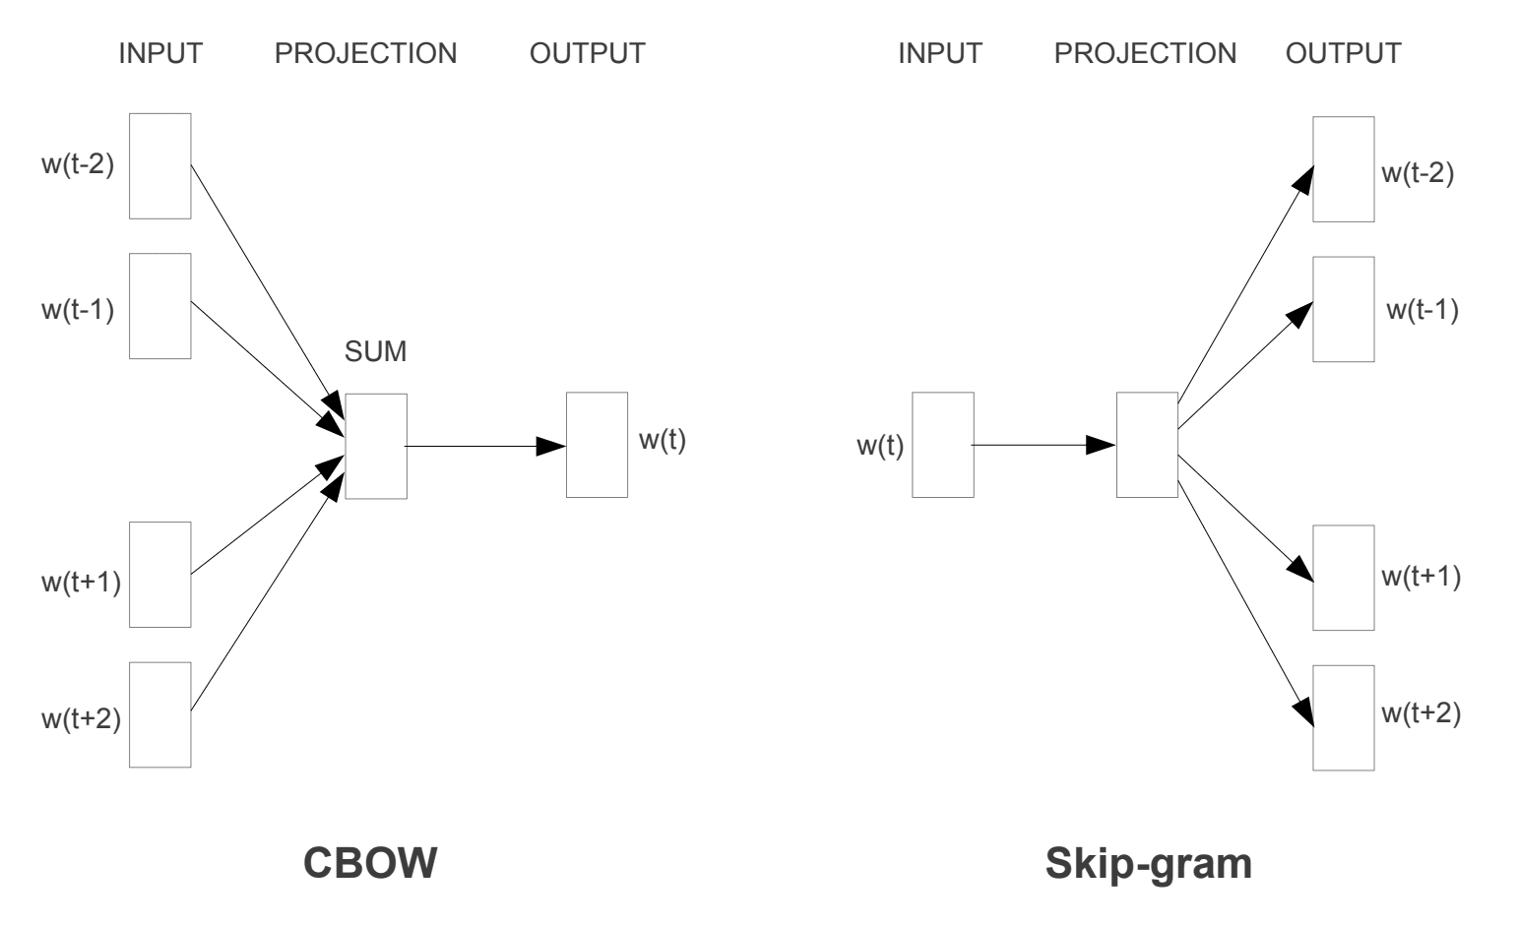On the other hand, CBOW is faster and has better representations for more frequent words.

OOPS =>

class Dog:

def __init__(self, name, age):

self.name = name

self.age = age

class Dog:

species = "Canis familiaris"

def __init__(self, name, age):

self.name = name

self.age = age

# Instance method

def description(self):

return f"{self.name} is {self.age} years old"

# Another instance method

def speak(self, sound):

return f"{self.name} says {sound}"

class JackRussellTerrier(Dog):

def speak(self, sound="Arf"):

return f"{self.name} says {sound}"

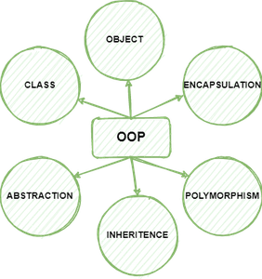

Activity diagram

<https://github.com/tssovi/grokking-the-object-oriented-design-interview>

**What is the difference between Activity diagram and Sequence diagram?**

**Activity diagram** captures the process flow. It is used for functional modeling. A functional model represents the flow of values from external inputs, through operations and internal data stores, to external outputs.

**Sequence diagram** tracks the interaction between the objects. It is used for dynamic modeling, which is represented by tracking states, transitions between states, and the events that trigger these transitions.

**Types of UML Diagrams:** The current UML standards call for 14 different kinds of diagrams. These diagrams are organized into two distinct groups: structural diagrams and behavioral or interaction diagrams. As the names suggest, some UML diagrams analyze and depict the structure of a system or process, whereas others describe the behavior of the system, its actors, and its building components. The different types are broken down as follows:

**Structural UML diagrams**

* Class diagram
* Object diagram
* Package diagram
* Component diagram
* Composite structure diagram
* Deployment diagram
* Profile diagram

**Behavioral UML diagrams**

* Use case diagram
* Activity diagram
* Sequence diagram
* State diagram
* Communication diagram
* Interaction overview diagram
* Timing diagram

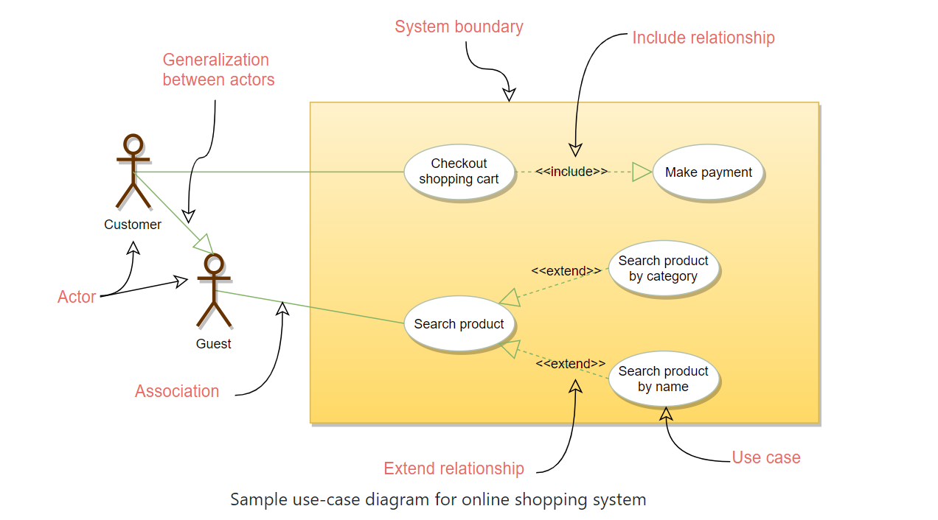

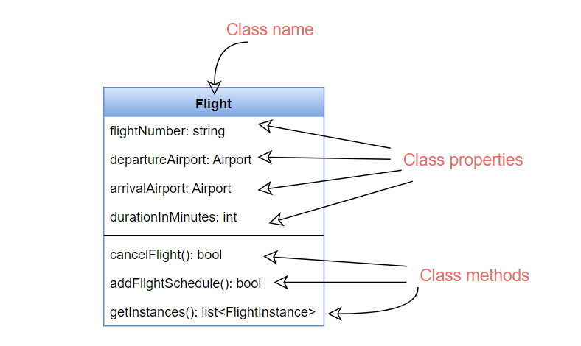

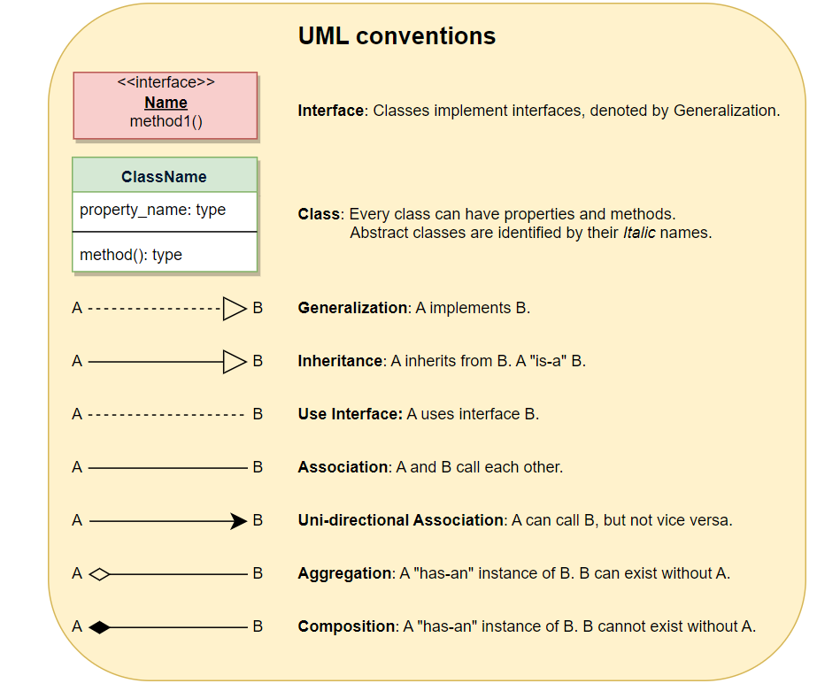

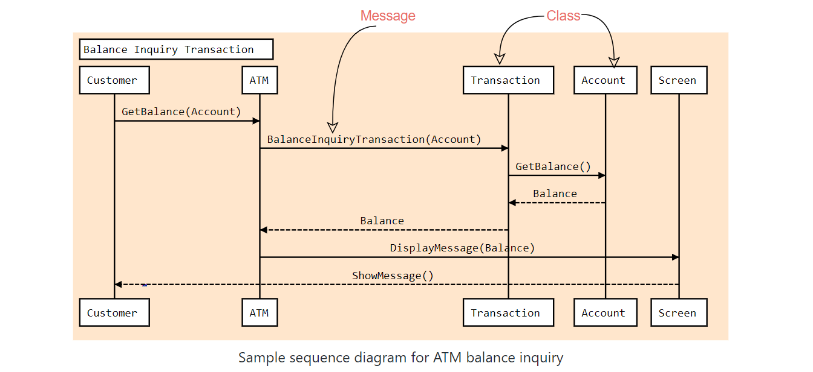

<https://github.com/tssovi/grokking-the-object-oriented-design-interview/blob/master/object-oriented-design-case-studies/design-facebook.md>

from enum import Enum

class ConnectionInvitationStatus(Enum):

PENDING, ACCEPTED, REJECTED, CANCELED = 1, 2, 3, 4

class AccountStatus(Enum):

ACTIVE, CLOSED, CANCELED, BLACKLISTED, DISABLED = 1, 2, 3, 4, 5

class Address:

def __init__(self, street, city, state, zip_code, country):

self.__street_address = street

self.__city = city

self.__state = state

self.__zip_code = zip_code

self.__country = country

from datetime import datetime

class Page:

def __init__(self, id, name, description, type, total_members):

self.__page_id = id

self.__name = name

self.__description = description

self.__type = type

self.__total_members = total_members

self.__recommendation = []

def get_recommendation(self):

return self.__recommendation

class Recommendation:

def __init__(self, id, rating, description):

self.__recommendation_id = id

self.__rating = rating

self.__description = description

self.__created_at = datetime.date.today()

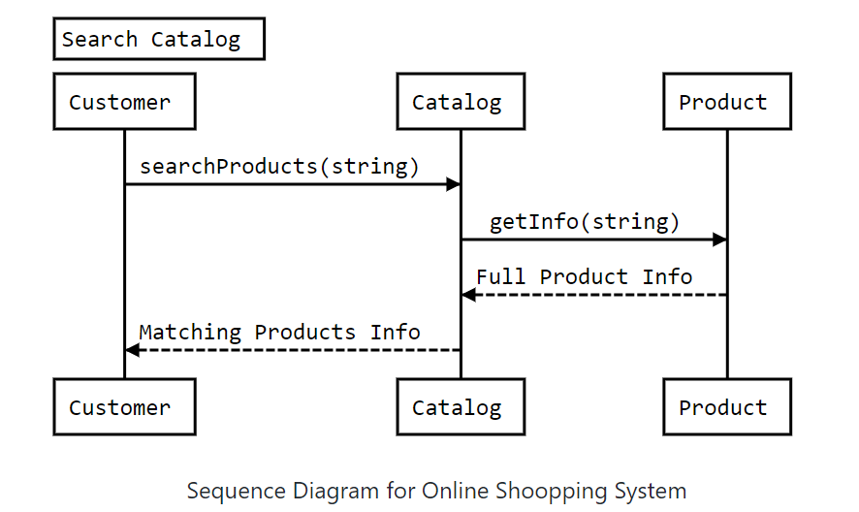

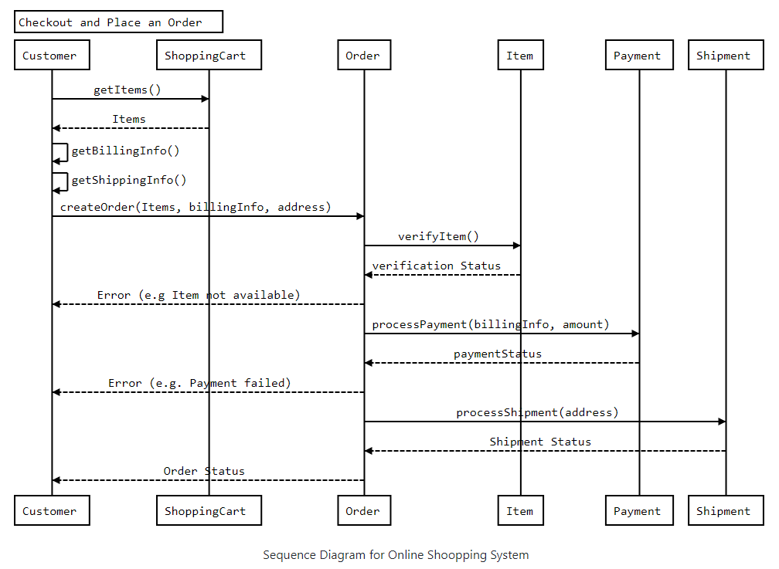

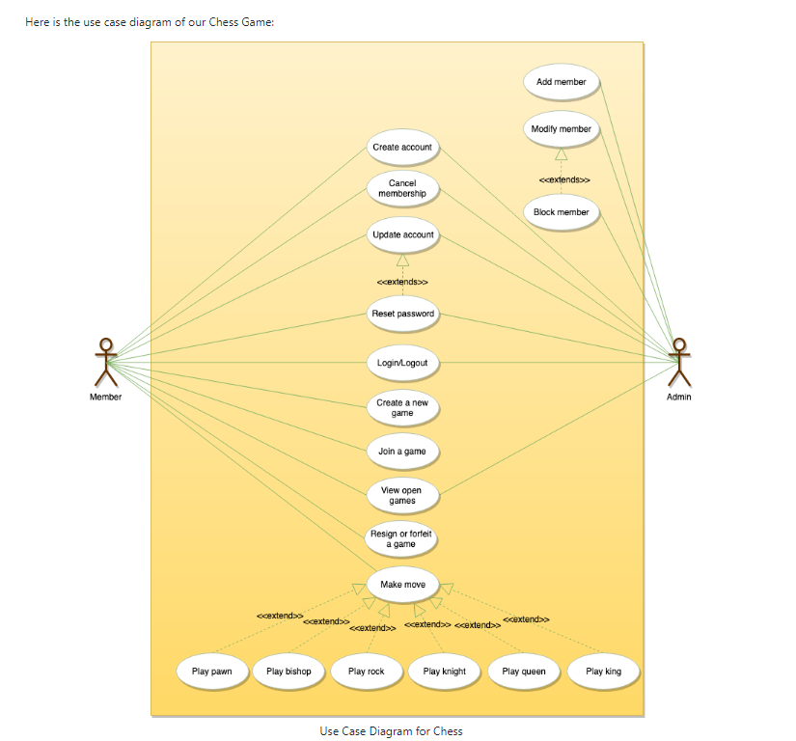

**Use Case Diagram**

Here are the actors of the ATM system and their use cases:

**Operator:** The operator will be responsible for the following operations:

1. Turning the ATM ON/OFF using the designated Key-Switch.
2. Refilling the ATM with cash.
3. Refilling the ATM’s printer with receipts.
4. Refilling the ATM’s printer with INK.
5. Take out deposited cash and checks.

**Customer:** The ATM customer can perform the following operations:

1. Balance inquiry: the user can view his/her account balance.
2. Cash withdrawal: the user can withdraw a certain amount of cash.
3. Deposit funds: the user can deposit cash or checks.
4. Transfer funds: the user can transfer funds to other accounts.

**Bank Manager:** The Bank Manager can perform the following operations:

1. Generate a report to check total deposits.
2. Generate a report to check total withdrawals.
3. Print total deposits/withdrawal reports.
4. Checks the remaining cash in the ATM.

Here is the use case diagram of our ATM system:

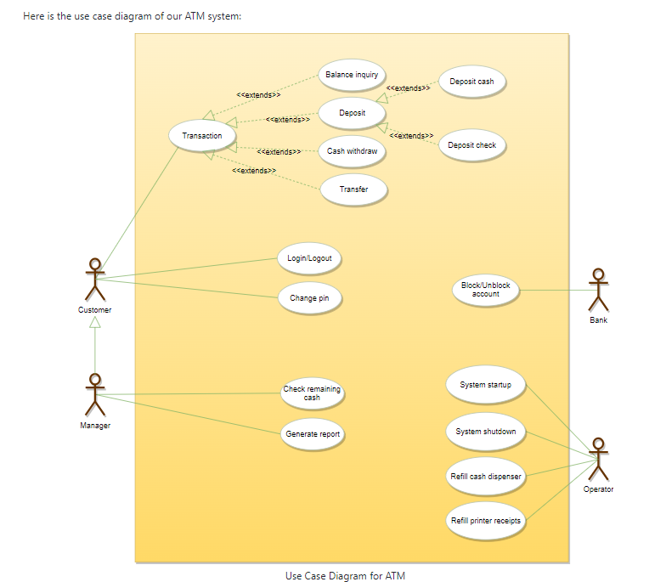

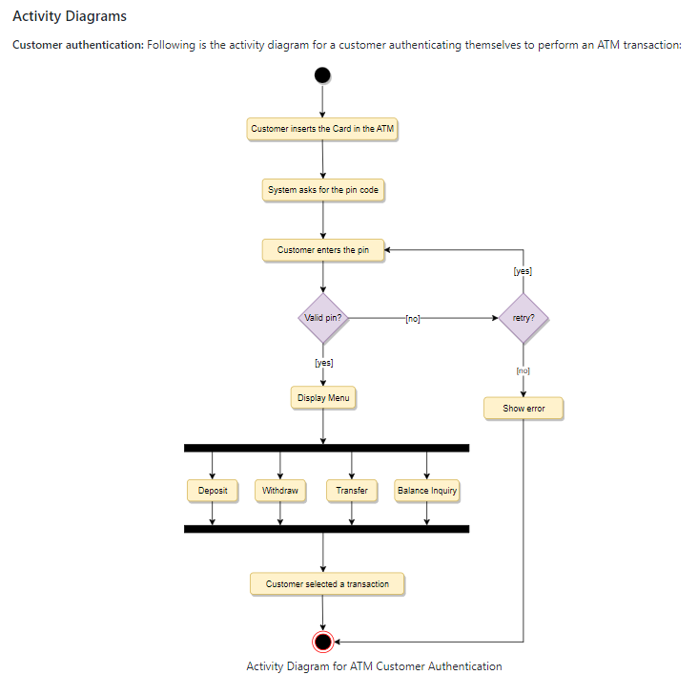

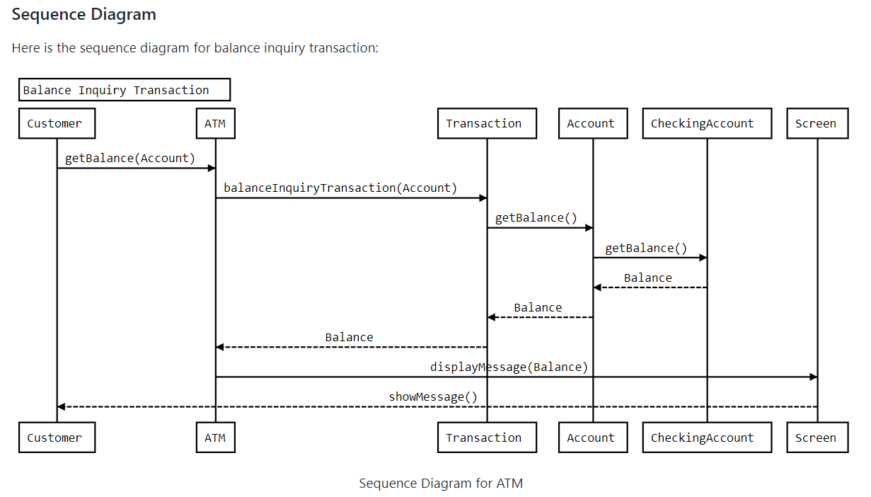

#### **Annotations for Junit testing**

The Junit 4.x framework is annotation based, so let's see the annotations that can be used while writing the test cases.

**@Test** annotation specifies that method is the test method.

**@Test(timeout=1000)** annotation specifies that method will be failed if it takes longer than 1000 milliseconds (1 second).

**@BeforeClass** annotation specifies that method will be invoked only once, before starting all the tests.

**@Before** annotation specifies that method will be invoked before each test.

**@After** annotation specifies that method will be invoked after each test.

**@AfterClass** annotation specifies that method will be invoked only once, after finishing all the tests.

## **Assert class**

The org.junit.Assert class provides methods to assert the program logi

1. **void assertEquals(boolean expected,boolean actual)**: checks that two primitives/objects are equal. It is overloaded.
2. **void assertTrue(boolean condition)**: checks that a condition is true.
3. **void assertFalse(boolean condition)**: checks that a condition is false.
4. **void assertNull(Object obj)**: checks that object is null.
5. **void assertNotNull(Object obj)**: checks that object is not null.

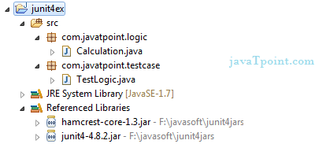

1. **package** com.javatpoint.testcase;
3. **import** **static** org.junit.Assert.*;
4. **import** com.javatpoint.logic.*;
5. **import** org.junit.Test;
7. **public** **class** TestLogic {
9. @Test
10. **public** **void** testFindMax(){
11. assertEquals(4,Calculation.findMax(**new** **int**[]{1,3,4,2}));
12. assertEquals(-1,Calculation.findMax(**new** **int**[]{-12,-1,-3,-4,-2}));
13. }
14. }
15. **package** com.javatpoint.testcase;
17. **import** **static** org.junit.Assert.assertEquals;
18. **import** org.junit.After;
19. **import** org.junit.AfterClass;
20. **import** org.junit.Before;
21. **import** org.junit.BeforeClass;
22. **import** org.junit.Test;
23. **import** com.javatpoint.logic.Calculation;
25. **public** **class** TestCase2 {
27. @BeforeClass
28. **public** **static** **void** setUpBeforeClass() **throws** Exception {
29. System.out.println("before class");
30. }
31. @Before
32. **public** **void** setUp() **throws** Exception {
33. System.out.println("before");
34. }
36. @Test
37. **public** **void** testFindMax(){
38. System.out.println("test case find max");
39. assertEquals(4,Calculation.findMax(**new** **int**[]{1,3,4,2}));
40. assertEquals(-2,Calculation.findMax(**new** **int**[]{-12,-3,-4,-2}));
41. }
42. @Test
43. **public** **void** testCube(){
44. System.out.println("test case cube");
45. assertEquals(27,Calculation.cube(3));
46. }
47. @Test
48. **public** **void** testReverseWord(){
49. System.out.println("test case reverse word");
50. assertEquals("ym eman si nahk",Calculation.reverseWord("my name is khan");
51. }
52. @After
53. **public** **void** tearDown() **throws** Exception {
54. System.out.println("after");
55. }
57. @AfterClass
58. **public** **static** **void** tearDownAfterClass() **throws** Exception {
59. System.out.println("after class");
60. }
62. }

<**dependency**> <**groupId**>org.junit.jupiter</**groupId**> <**artifactId**>junit-jupiter-engine</**artifactId**> <**version**>5.8.1</**version**> <**scope**>test</**scope**> </**dependency**>

@AfterEach

void tearDown() {

log.info("@AfterEach - executed after each test method.");

}

@AfterAll

static void done() {

log.info("@AfterAll - executed after all test methods.");

}

@DisplayName("Single test successful")

@Test

void testSingleSuccessTest() {

log.info("Success");

}

@Test

@Disabled("Not implemented yet")

void testShowSomething() {

}

Assertions have been moved to org.junit.jupiter.api.Assertions, and have been significantly improved. As mentioned earlier, we can now use lambdas in assertions:

<https://www.baeldung.com/junit-5>

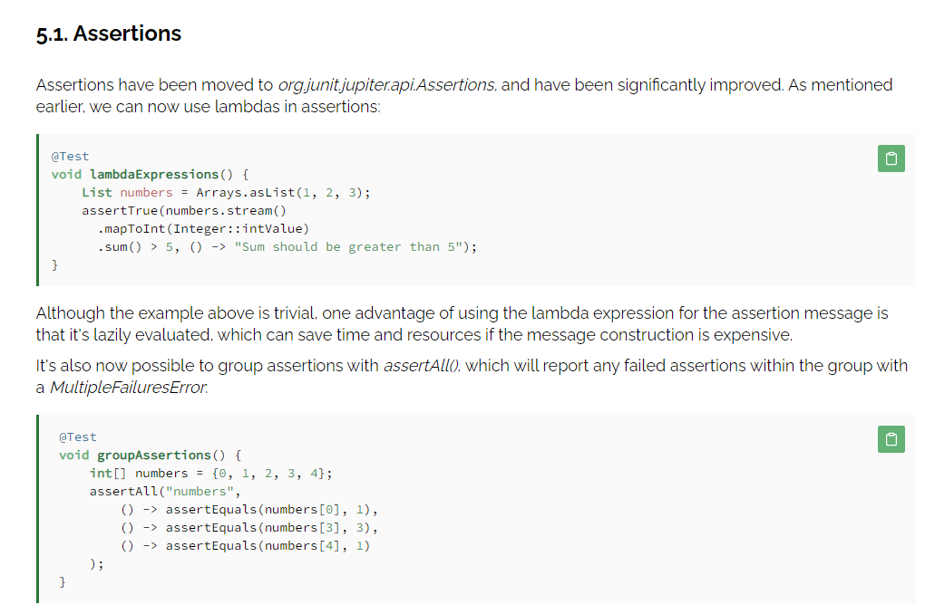

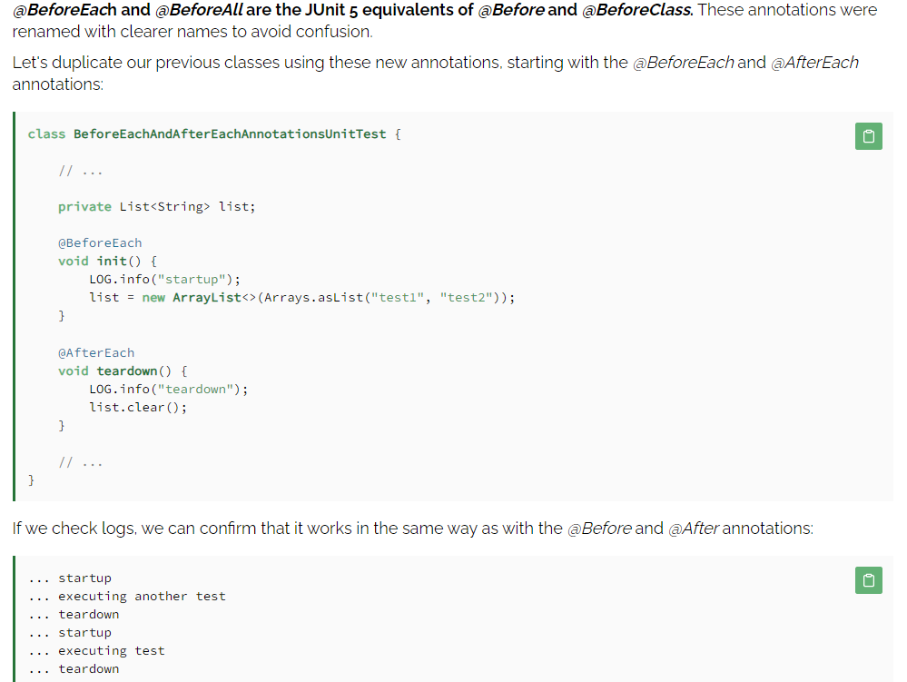

## **What is Mocking?**

Mocking is a process of developing the objects that act as the **mock** or **clone** of the real objects. In other words, mocking is a testing technique where mock objects are used instead of real objects for testing purposes. Mock objects provide a specific (dummy) output for a particular (dummy) input passed to it.

The brief description of the mocking concepts is given below:

1. **Stub:** Stub objects hold predefined data and provide it to answer the calls during testing. They are referred to as a dummy object with a minimum number of methods required for a test. It also provides methods to verify other methods used to access the internal state of a stub, when necessary. Stub object is generally used for **state verification**.
2. **Fake:** Fake are the objects that contain working implementations but are different from the production one. Mostly it takes shortcuts and also contains the simplified version of the production code.
3. **Mock:** Mock objects act as a dummy or clone of the real object in testing. They are generally created by an open-source library or a mocking framework like Mockito, EasyMock, etc. Mock objects are typically used for **behavior verification**.

ToDoService doService = mock(ToDoService.**class**);

when(mock.someCode ()).thenReturn(5);

## **Mockito spy() method**

Mockito provides a method to partially mock an object, which is known as the **spy** method. When using the spy method, there exists a real object, and spies or stubs are created of that real object. If we don't stub a method using spy, it will call the real method behavior. The main function of the spy() method is that it overrides the specific methods of the real object. One of the functions of the spy() method is it verifies the invocation of a certain method.

1. **import** java.util.Arrays;
2. **import** java.util.List;
4. **public** **class** ToDoServiceStub **implements** ToDoService   {
6. **public** List<String> getTodos(String user) {
8. **return** Arrays.asList(" Use Core Java ", " Use Spring Core ", " Use Hibernate ", " Use Spring MVC ");
9. }
10. }

@BeforeEach

void init(@Mock SettingRepository settingRepository) {

userService = new DefaultUserService(userRepository, settingRepository, mailClient);

Mockito.lenient().when(settingRepository.getUserMinAge()).thenReturn(10);

when(settingRepository.getUserNameMinLength()).thenReturn(4);

Mockito.lenient()

.when(userRepository.isUsernameAlreadyExists(any(String.class)))

.thenReturn(false);

}

Example of BDD style

Here, we are going to create an example of a BDD style test. Switching to BDD style makes a minor difference only in the test syntax. It splits the test syntax into three parts: **given, when,** and **then** that makes the code more readable.

* **Given:** We can use the setup part and the given kind of syntax.
* **When:** We can do the actual invocations of the test.
* **Then:** We can use the readable **asserts** like **assertThat()** and can also check whether the post-conditions are satisfied or not.

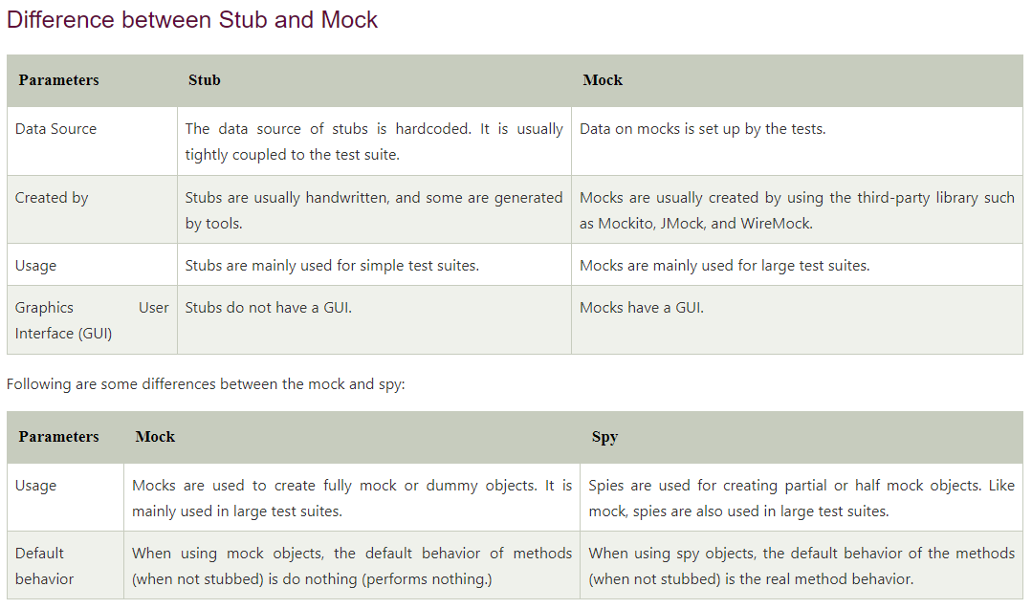

Agile is an iterative approach to project management and software development that helps teams deliver value to their customers faster and with fewer headaches. Instead of betting everything on a "big bang" launch, an agile team delivers work in small, but consumable, increments.

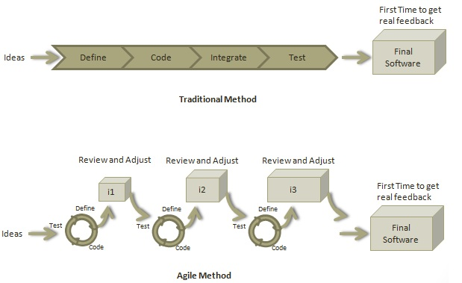

## **What is a User Story?**

A user story is a requirement which defines what is required by the user as functionality. A user story can be in two forms −

* As a <User Role> I want <Functionality> so that <Business Value>
* In order to <Business value> as a <User Role> I want <Functionality>

During release planning, a rough estimate is given to a user story using relative scale as points. During iteration planning, the story is broken down into tasks.

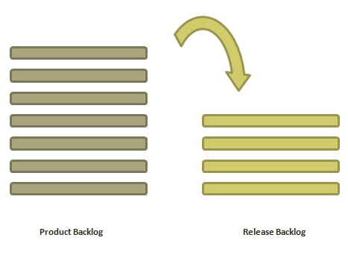

## Stages of a CI/CD pipeline

A CI/CD pipeline is a runnable specification of the steps that any developer should perform to deliver a new version of any software. Failure in each and every stage triggers a notification via email, Slack, or other communication platforms. It enables responsible developers to know about the important issues.

Here are the important Stages of CI/CD pipeline:

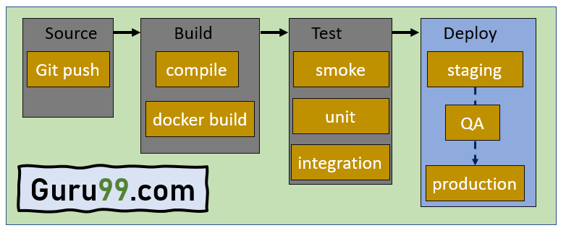

A basic **declarative** Jenkinsfile pipeline is simpler to understand. An example looks like the following:

pipeline {

agent any

stages {

stage('Build') {

steps {

echo 'Building…'

}

}

stage('Test') {

steps {

echo 'Testing…'

}

}

stage('Deploy') {

steps {

echo 'Deploying...'

}

}

}

}

The code has the following elements:

* The mandatory **pipeline { }** block invokes the Jenkins Pipeline plugin.
* The keyword **agent** defines where the Pipeline runs, where **any** indicates the Pipeline runs on any available agent.
* The **stages { }** block represents the sequence in which the Pipeline runs.
* The code contains three stages: **Build**, **Test** and **Deploy**, each with its respective **steps { }**.
* The **steps { }** tell Jenkins what to do at a particular point.

### Automated Testing

[Automated testing](https://phoenixnap.com/blog/best-automation-testing-tools) for Jenkins presets test execution and stores the results. The idea is to ensure code works in various scenarios. Creating automated tests for distinct environments, such as several [Java versions](https://phoenixnap.com/kb/check-java-version-on-mac-windows) or operating systems, helps foresee and prevent problems in later releases.

The automated testing phases embed into the CI pipeline in Jenkins seamlessly. Various plugins help run unit, integration, functional, and regression tests and store the results for later viewing and analysis.

### Project (Formerly Job)

A Jenkins project, or a job, is a user-made automation procedure with a particular goal. Jenkins offers various build jobs by default, and more are available through plugins.

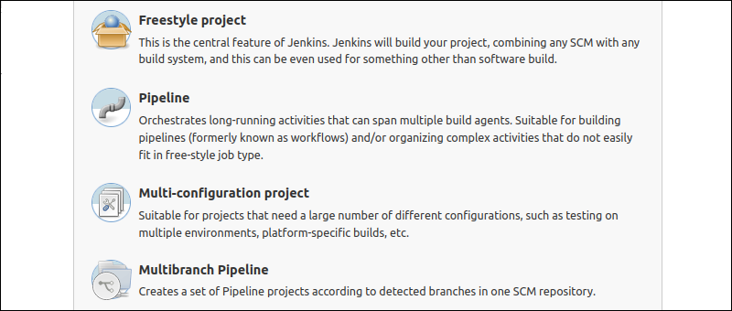

Jenkins provides us with various interfaces and tools in order to automate the entire process.

1. We will create a git repository or use an existing one
2. Dev team have the responsibility to commit the code to Dev-Branch
3. Jenkins will fetch the code from Github and will map with the job enabled for a specific task
4. We will make sure that CI and CD is done for the job/task
5. Jenkins will pull the code and will enter the commit phase of the task
6. Jenkins then will compile code and its called build phase of the task
7. The code is deployed by Jenkins after the code is merged to Master branch by DevOps team and the job is started for a specific application
8. The code is ready to be deployed and enter the deployment phase cycle
9. The code after deployed from Jenkins then get deployed to the server using docker container
10. After the code is working fine in staging server with unit testing, Same code then is deployed on the production server

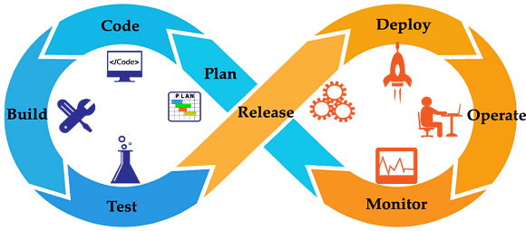

public class BrandRepository {

private final List<Brand> brands;

public BrandRepository(List<Brand> brands) {

this.brands = ImmutableList.copyOf(brands);

}

public List<Brand> findAll(int size) {

return brands.stream()

.limit(size)

.collect(Collectors.toList());

}

public Optional<Brand> findById(Long id) {

return brands.stream()

.filter(brand -> brand.getId().equals(id))

.findFirst();

}

}

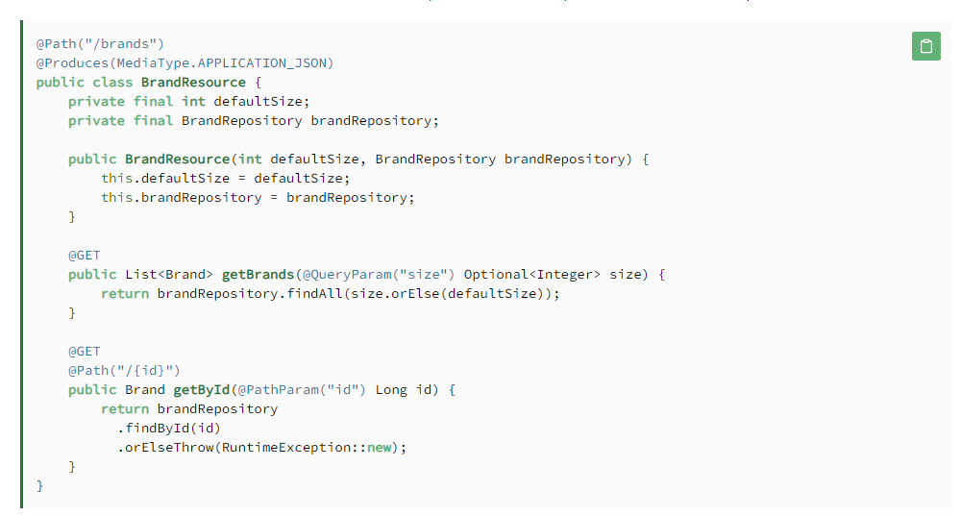

**Restful Web Services Annotations**

Some of the important JAX-RS annotations are:

* @Path: used to specify the relative path of class and methods. We can get the URI of a webservice by scanning the Path annotation value.
* @GET, @PUT, @POST, @DELETE and @HEAD: used to specify the HTTP request type for a method.
* @Produces, @Consumes: used to specify the request and response types.
* @PathParam: used to bind the method parameter to path value by parsing it.

### REST API Implementations

There are two major implementations of JAX-RS API.

1. **Jersey**: [Jersey](https://jersey.github.io/) is the reference implementation provided by Sun. For using Jersey as our JAX-RS implementation, all we need to configure its servlet in web.xml and add required dependencies. Note that JAX-RS API is part of JDK not Jersey, so we have to add its dependency jars in our application.
2. **RESTEasy**: [RESTEasy](https://resteasy.github.io/) is the JBoss project that provides JAX-RS implementation.

|  |
| --- |
|  |
| @PutMapping(value = "/update/{GuestId}") |
|  |  |  | @ApiOperation("To Update a Guest") |
|  |  |  | @ApiResponse(code = 200, message = "Successfully Updated Guest") |
|  |  |  | public ResponseEntity<GuestDTO> updateGuest(GuestDTO guestDTO) { |
|  |  |  | return ResponseEntity.ok(guestService.updateGuest(guestDTO)); |
|  |  |  | } |
|  |  |  |  |

## The [**Model-View-Controller (MVC)**](https://www.geeksforgeeks.org/mvc-design-pattern/) framework is an architectural/design pattern that separates an application into three main logical components **Model**, **View**, and **Controller**. Each architectural component is built to handle specific development aspects of an application.

## 

**Controller:**

The controller is the component that enables the interconnection between the views and the model so it acts as an intermediary. The controller doesn’t have to worry about handling data logic, it just tells the model what to do. It process all the business logic and incoming requests, manipulate data using the **Model**component and interact with the **View**to render the final output.

**View:**

The **View**component is used for all the UI logic of the application. It generates a user interface for the user. Views are created by the data which is collected by the model component but these data aren’t taken directly but through the controller. It only interacts with the controller.

**Model:**

The **Model**component corresponds to all the data-related logic that the user works with. This can represent either the data that is being transferred between the View and Controller components or any other business logic-related data. It can add or retrieve data from the database. It responds to the controller’s request because the controller can’t interact with the database by itself. The model interacts with the database and gives the required data back to the controller.

## 

## **Core Java Design Patterns**

In core java, there are mainly three types of design patterns, which are further divided into their sub-parts:

## **1.Creational Design Pattern**

1. Factory Pattern
2. Abstract Factory Pattern
3. Singleton Pattern
4. Prototype Pattern
5. Builder Pattern.

## **2. Structural Design Pattern**

1. Adapter Pattern
2. Bridge Pattern
3. Composite Pattern
4. Decorator Pattern
5. Facade Pattern
6. Flyweight Pattern
7. Proxy Pattern

## **3. Behavioral Design Pattern**

1. Chain Of Responsibility Pattern
2. Command Pattern
3. Interpreter Pattern
4. Iterator Pattern
5. Mediator Pattern
6. Memento Pattern
7. Observer Pattern
8. State Pattern
9. Strategy Pattern
10. Template Pattern
11. Visitor Pattern

# **Creational design patterns**

Creational design patterns are concerned with**the way of creating objects.** These design patterns are used when a decision must be made at the time of instantiation of a class (i.e. creating an object of a class).

# **Factory Method Pattern**

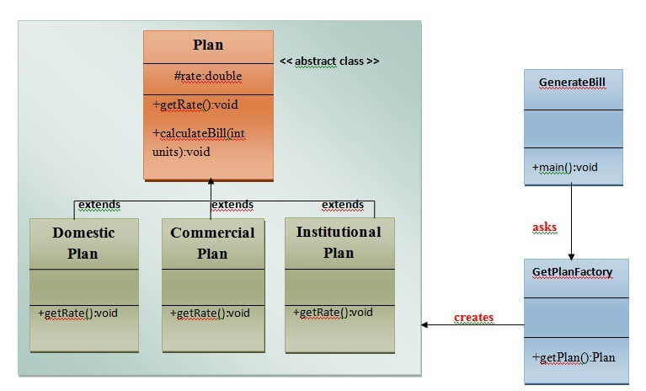

1. **class** GetPlanFactory{
3. //use getPlan method to get object of type Plan
4. **public** Plan getPlan(String planType){
5. **if**(planType == **null**){
6. **return** **null**;
7. }
8. **if**(planType.equalsIgnoreCase("DOMESTICPLAN")) {
9. **return** **new** DomesticPlan();
10. }
11. **else** **if**(planType.equalsIgnoreCase("COMMERCIALPLAN")){
12. **return** **new** CommercialPlan();
13. }
14. **else** **if**(planType.equalsIgnoreCase("INSTITUTIONALPLAN")) {
15. **return** **new** InstitutionalPlan();
16. }
17. **return** **null**;
18. }
19. }//end of GetPlanFactory class.

# **Abstract Factory Pattern**

Abstract Factory Pattern says that just **define an interface or abstract class for creating families of related (or dependent) objects but without specifying their concrete sub-classes.**That means Abstract Factory lets a class returns a factory of classes. So, this is the reason that Abstract Factory Pattern is one level higher than the Factory Pattern.

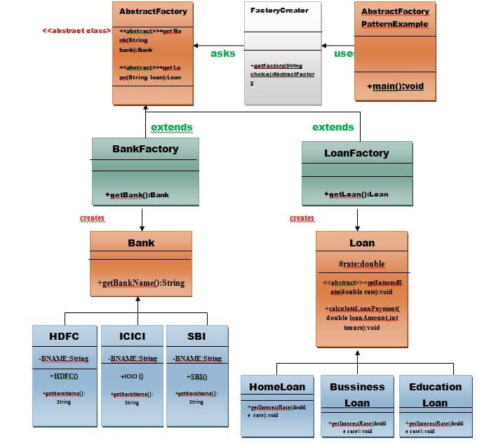

# **Singleton design pattern in Java**

Singleton Pattern says that just**"define a class that has only one instance and provides a global point of access to it".**

In other words, a class must ensure that only single instance should be created and single object can be used by all other classes

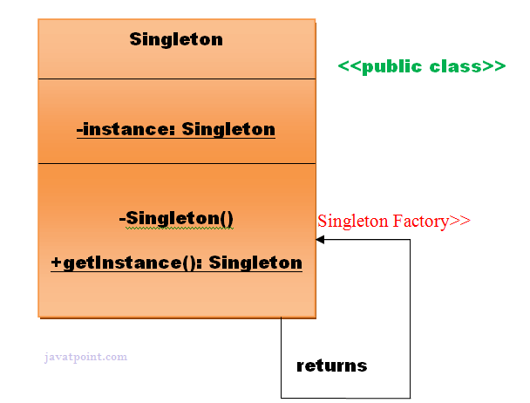

# **Prototype Design Pattern**

Prototype Pattern says that **cloning of an existing object instead of creating new one and can also be customized as per the requirement**.

This pattern should be followed, if the cost of creating a new object is expensive and resource intensive.

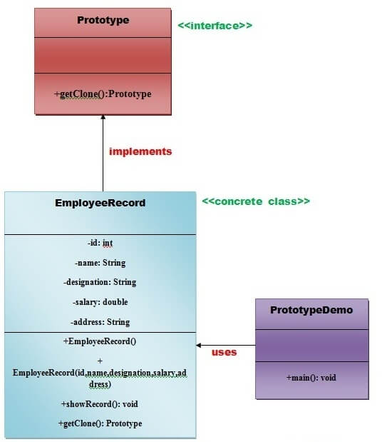

# **Adapter Pattern**

An Adapter Pattern says that just **"converts the interface of a class into another interface that a client wants".**

In other words, to provide the interface according to client requirement while using the services of a class with a different interface.

The Adapter Pattern is also known as **Wrapper.**

# What is Normalization in DBMS (SQL)? 1NF, 2NF, 3NF Example

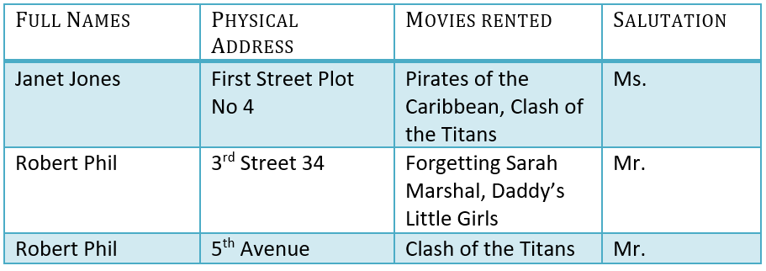

## **1NF (First Normal Form) Rules**

* Each table cell should contain a single value.
* Each record needs to be unique.

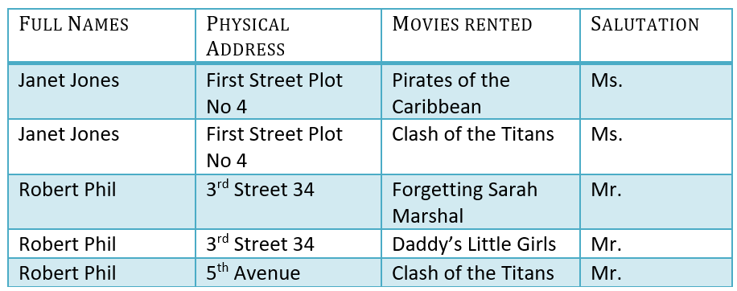

* A [primary key](https://www.guru99.com/dbms-keys.html) cannot be NULL
* A primary key value must be unique
* The primary key values should rarely be changed
* The primary key must be given a value when a new record is inserted

### What is Composite Key?

A composite key is a primary key composed of multiple columns used to identify a record uniquely

In our database, we have two people with the same name Robert Phil, but they live in different places.

## 2NF (Second Normal Form) Rules

* Rule 1- Be in 1NF
* Rule 2- Single Column Primary Key that does not functionally dependant on any subset of candidate key relation

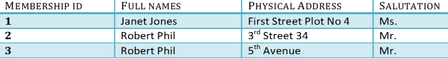

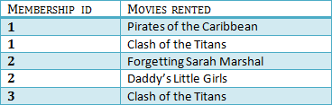

## 3NF (Third Normal Form) Rules

* Rule 1- Be in 2NF
* Rule 2- Has no transitive functional dependencies

To move our 2NF table into 3NF, we again need to again divide our table.

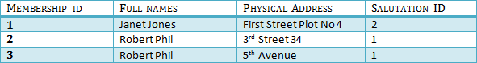

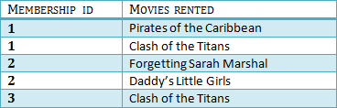

## BCNF (Boyce-Codd Normal Form)

Even when a database is in 3rd Normal Form, still there would be anomalies resulted if it has more than one **Candidate**Key.

Sometimes is BCNF is also referred as **3.5 Normal Form.**

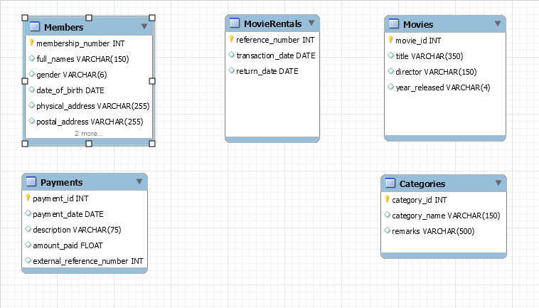

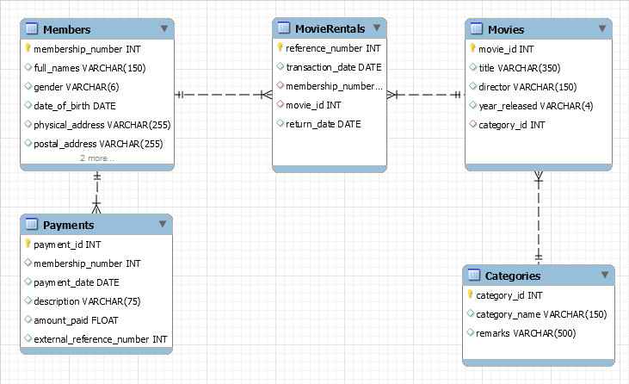

## Database development life cycle

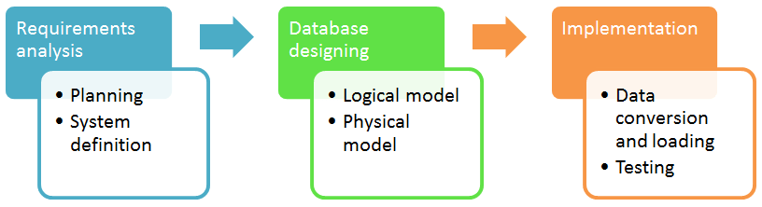

## **Entity**

An entity can be a real-world object, either animate or inanimate, that can be easily identifiable. For example, in a school database, students, teachers, classes, and courses offered can be considered as entities. All these entities have some attributes or properties that give them their identity.

## **Attributes**

Entities are represented by means of their properties, called **attributes**. All attributes have values. For example, a student entity may have name, class, and age as attributes.

There exists a domain or range of values that can be assigned to attributes. For example, a student's name cannot be a numeric value. It has to be alphabetic. A student's age cannot be negative, etc.

### Types of Attributes

* **Simple attribute** − Simple attributes are atomic values, which cannot be divided further. For example, a student's phone number is an atomic value of 10 digits.
* **Composite attribute** − Composite attributes are made of more than one simple attribute. For example, a student's complete name may have first_name and last_name.
* **Derived attribute** − Derived attributes are the attributes that do not exist in the physical database, but their values are derived from other attributes present in the database. For example, average_salary in a department should not be saved directly in the database, instead it can be derived. For another example, age can be derived from data_of_birth.
* **Single-value attribute** − Single-value attributes contain single value. For example − Social_Security_Number.
* **Multi-value attribute** − Multi-value attributes may contain more than one values. For example, a person can have more than one phone number, email_address, etc.

### Entity-Set and Keys

Key is an attribute or collection of attributes that uniquely identifies an entity among entity set.

For example, the roll_number of a student makes him/her identifiable among students.

* **Super Key** − A set of attributes (one or more) that collectively identifies an entity in an entity set.
* **Candidate Key** − A minimal super key is called a candidate key. An entity set may have more than one candidate key.
* **Primary Key** − A primary key is one of the candidate keys chosen by the database designer to uniquely identify the entity set.

## **Generalization**

As mentioned above, the process of generalizing entities, where the generalized entities contain the properties of all the generalized entities, is called generalization. In generalization, a number of entities are brought together into one generalized entity based on their similar characteristics. For example, pigeon, house sparrow, crow and dove can all be generalized as Birds.

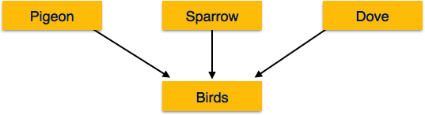

## **Specialization**

Specialization is the opposite of generalization. In specialization, a group of entities is divided into sub-groups based on their characteristics. Take a group ‘Person’ for example. A person has name, date of birth, gender, etc. These properties are common in all persons, human beings. But in a company, persons can be identified as employee, employer, customer, or vendor, based on what role they play in the company.

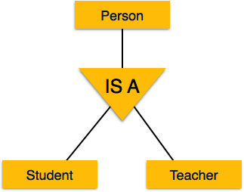

## **Second Normal Form**

Before we learn about the second normal form, we need to understand the following −

* **Prime attribute** − An attribute, which is a part of the candidate-key, is known as a prime attribute.
* **Non-prime attribute** − An attribute, which is not a part of the prime-key, is said to be a non-prime attribute.

If we follow second normal form, then every non-prime attribute should be fully functionally dependent on prime key attribute. That is, if X → A holds, then there should not be any proper subset Y of X, for which Y → A also holds true.

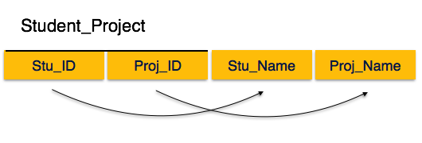

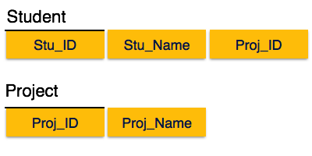

## **Third Normal Form**

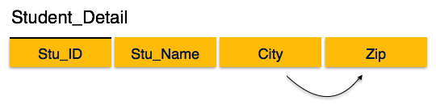

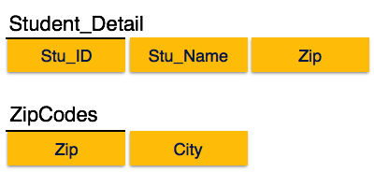

## **Boyce-Codd Normal Form**

Boyce-Codd Normal Form (BCNF) is an extension of Third Normal Form on strict terms. BCNF states that −

* For any non-trivial functional dependency, X → A, X must be a super-key.

In the above image, Stu_ID is the super-key in the relation Student_Detail and Zip is the super-key in the relation ZipCodes. So,

Stu_ID → Stu_Name, Zip

and

Zip → City

Which confirms that both the relations are in BCNF.

**Docker**

Docker is a container management service. The keywords of Docker are **develop, ship** and **run** anywhere. The whole idea of Docker is for developers to easily develop applications, ship them into containers which can then be deployed anywhere.

In Docker, everything is based on Images. An image is a combination of a file system and parameters. Let’s take an example of the following command in Docker.

docker run hello-world

* The Docker command is specific and tells the Docker program on the Operating System that something needs to be done.
* The **run** command is used to mention that we want to create an instance of an image, which is then called a **container**.
* Finally, "hello-world" represents the image from which the container is made.

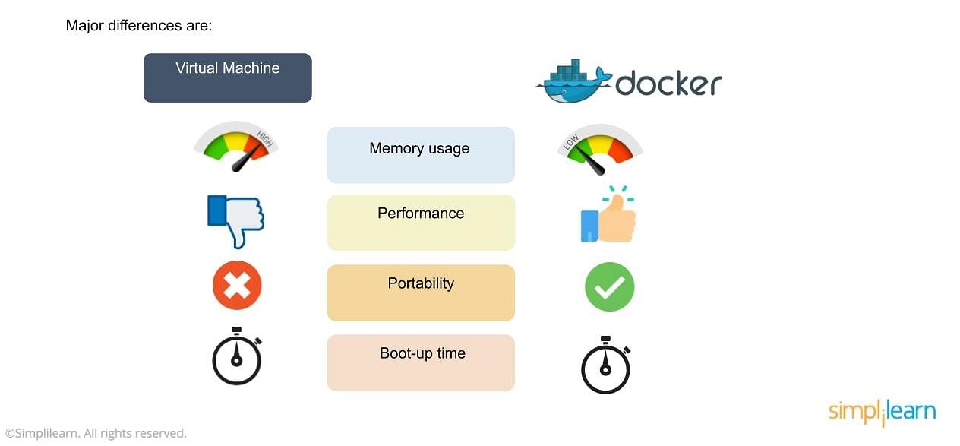

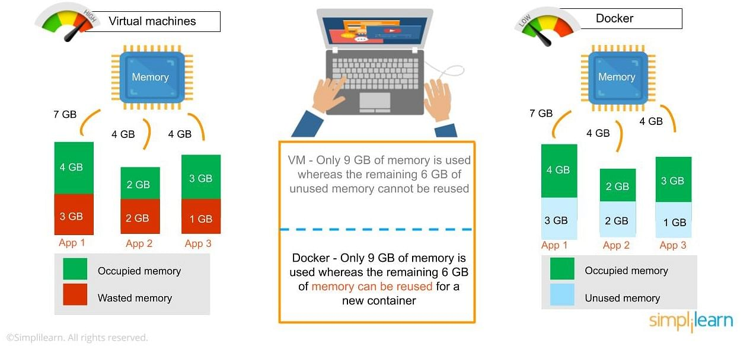

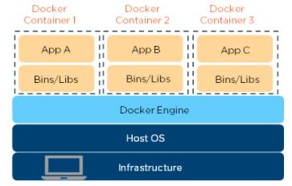

<https://towardsdatascience.com/build-and-run-a-docker-container-for-your-machine-learning-model-60209c2d7a7f>

We copy the train.csv, test.csv, train.py and inference.py files into the image. Then, we run **train.py** which will fit and serialize the machine learning models as part of our image build process which provide several advantages such as the ability to debug at the beginning of the process, use Docker Image ID for keeping track or use different versions.

|  |
| --- |
| FROM jupyter/scipy-notebook |
|  |  |
|  | RUN pip install joblib |
|  |  |
|  | COPY train.csv ./train.csv |
|  | COPY test.csv ./test.csv |
|  |  |
|  | COPY train.py ./train.py |
|  | COPY inference.py ./inference.py |
|  |  |
|  | RUN python3 train.py |

In order to build the image, we run the following command in our terminal:

docker build -t docker-ml-model -f Dockerfile .

It’s time to perform the inference on new data (test.csv):

docker run docker-ml-model python3 inference.py

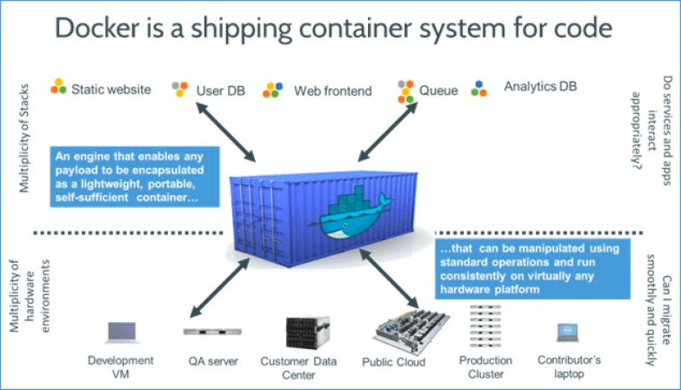

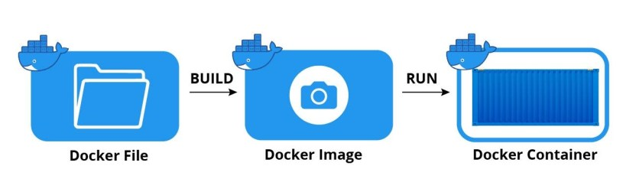

#### What is a Docker file?

A Dockerfile is a text document containing all the commands required to generate a specific image that is read by Docker to build that image automatically. There should be as little setting or updating as possible when creating an image using the docker image build command, so that containers may be paused and/or destroyed at any moment and rebuilt or replaced with little effort.

## **How To Deploy a Machine Learning Model Into Production**

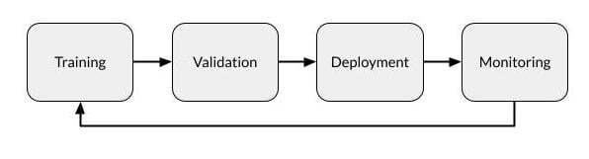

Every deployed model has the potential to degrade over time due to such issues as:

* **Variance in deployed data.** Often, the data given to the model in deployment is not cleaned in the same manner as the training and testing data were, resulting in changes in model deployment.
* **Changes in data integrity.**Over weeks, months or years, changes in data being fed to the model can adversely affect model performance, such as changes in formats, renamed fields or new categories.
* **Data drift.**Changes in demographics, market shifts and so on can cause drift over time, making the training data less relevant to the current situation and the model’s results therefore less precise.
* **Concept drift.** Changes in the end users’ expectations of what constitutes a correct prediction can change over time, making the model’s predictions less relevant.

# How Enterprise MLOps Works Throughout the Data Science Lifecycle

<https://www.dominodatalab.com/blog/how-enterprise-mlops-works-throughout-the-data-science-lifecycle>

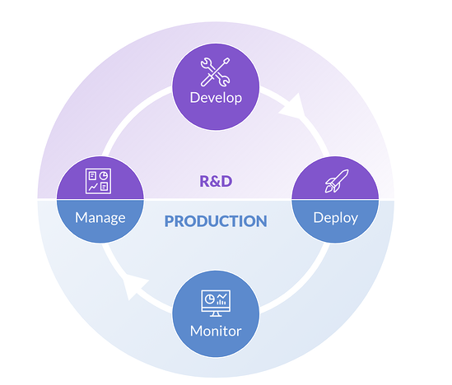

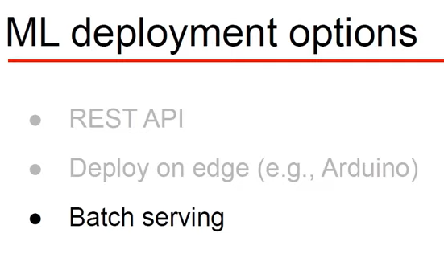

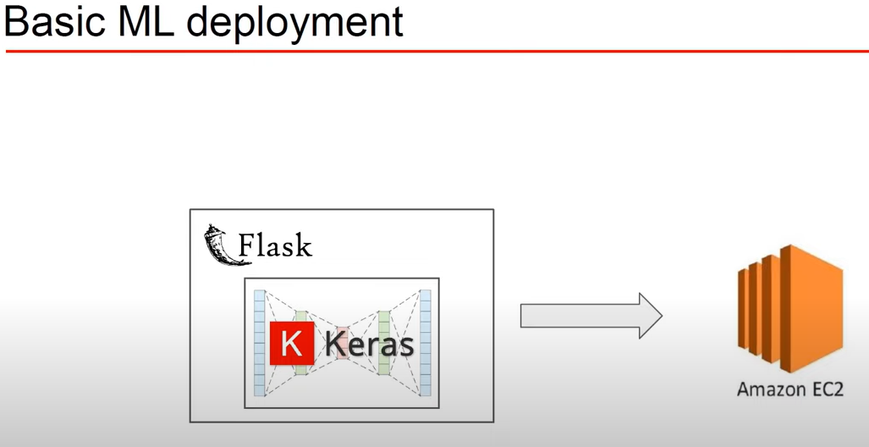

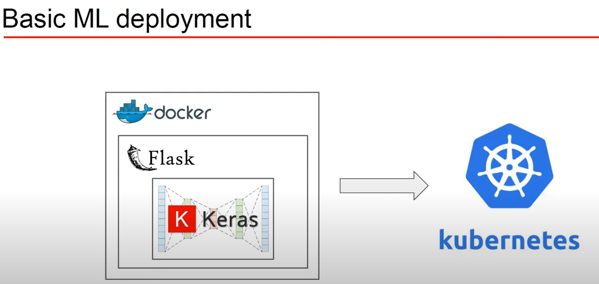

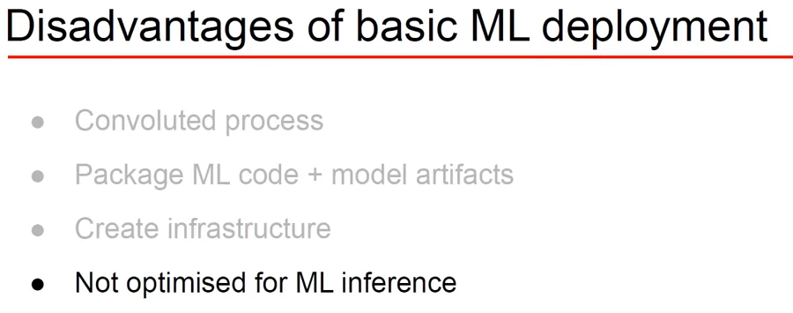

<https://github.com/sauravk90/ML-Model-Flask-Deployment>

**Project Structure**

This project has four major parts :

1. model.py - This contains code fot our Machine Learning model to predict employee salaries absed on trainign data in 'hiring.csv' file.
2. app.py - This contains Flask APIs that receives employee details through GUI or API calls, computes the precited value based on our model and returns it.
3. request.py - This uses requests module to call APIs already defined in app.py and dispalys the returned value.
4. templates - This folder contains the HTML template to allow user to enter employee detail and displays the predicted employee salary.

<https://k21academy.com/microsoft-azure/dp-100/how-to-deploy-azure-machine-learning-model-in-production/>

## **Steps To Deploy A ML Model Using Azure ML Designer**

In Azure Machine Learning we can deploy the trained model on **Inference Cluster**which will generate an endpoint that can be used by clients to use these models and make inferences on some new data.

**Note:**Before deploying the Inference Pipeline make sure you have created an Inference Cluster on which we will deploy the inference pipeline.

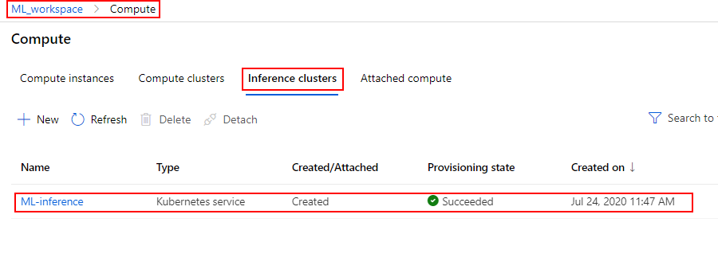

**1)**In the **Create inference pipeline** drop-down list, click a **Real-time inference pipeline**.

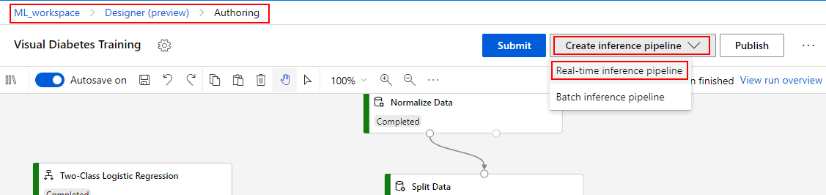

<https://github.com/prakhargurawa/mslearn-dp100/blob/main/09%20-%20Create%20a%20Real-time%20Inferencing%20Service.ipynb>

# Create a real-time inferencing service

The web service where we deploy the model will need some Python code to load the input data, get the model from the workspace, and generate and return predictions. We'll save this code in an *entry script* (often called a *scoring script*) that will be deployed to the web service.

The script consists of two functions:

* **init**: This fucntion is called when the service is initialized, and is generally used to load the model. Note that the scoring script uses the **AZUREML_MODEL_DIR** environment variable to determine the folder where the model is stored.
* **run**: This function is called each time a client application submits new data, and is generally used to inference predictions from the model.

You've deployed your web service as an Azure Container Instance (ACI) service that requires no authentication. This is fine for development and testing, but for production you should consider deploying to an Azure Kubernetes Service (AKS) cluster and enabling token-based authentication. This would require REST requests to include an **Authorization** header.

## Create compute

We'll need a compute context for the pipeline, so we'll use the following code to specify an Azure Machine Learning compute cluster (it will be created if it doesn't already exist).

**Important**: Change your-compute-cluster to the name of your compute cluster in the code below before running it! Cluster names must be globally unique names between 2 to 16 characters in length. Valid characters are letters, digits, and the - character.

The pipeline will need an environment in which to run, so we'll create a Conda specification that includes the packages that the code uses.

For getting hands-on experience on deploying a model, a simple problem has been taken here. The steps that are followed here while deploying the model are:

1. Registering the ML model

2.  Deploying the model

3. Accessing the endpoint for making the prediction

**1. Registering the model in Model Registry**

The model registry helps to keep a record of all the trained models in your machine learning workspace. The ML model can be either registered through the UI or by using the script. Here, we will register the model using the UI. Since I already had a workspace created, I am not creating a new one. For creating a workspace from your local system, you can use the below script. Within some time, a new workspace will be created in your resource group.

from azureml.core import Workspace

ws = Workspace.create(name='sample',

subscription_id='**********',

resource_group='sample_group',

create_resource_group=True,

location='location'

)

Before registering the model, you need to prepare the:

a) Scoring Script

b)  YAML file which contains the packages used by the model

The scoring script plays an intermediate role between the deployed model and the client who uses it. When the client sends the input data, the scoring script will receive the data and pass it to the model. It will return the model’s output to the client. The script contains mainly two functions.

(1)  init function

(2)  run function

init functions help to load your model and the run function to run your model on the input data that the client has passed.

import json

import numpy as np

import os

import pickle

import joblib

from sklearn.svm import SVC

from azureml.core import Model

def init():

global model

model_name = 'classifier'

path = Model.get_model_path(model_name)

model = joblib.load(path)

def run(data):

try:

data = json.loads(data)

result = model.predict(data['data'])

return {'data' : result.tolist() , 'message' : "Successfully classified Iris"}

except Exception as e:

error = str(e)

return {'data' : error , 'message' : 'Failed to classify iris'}

Save the above-written scripts in a .py file.

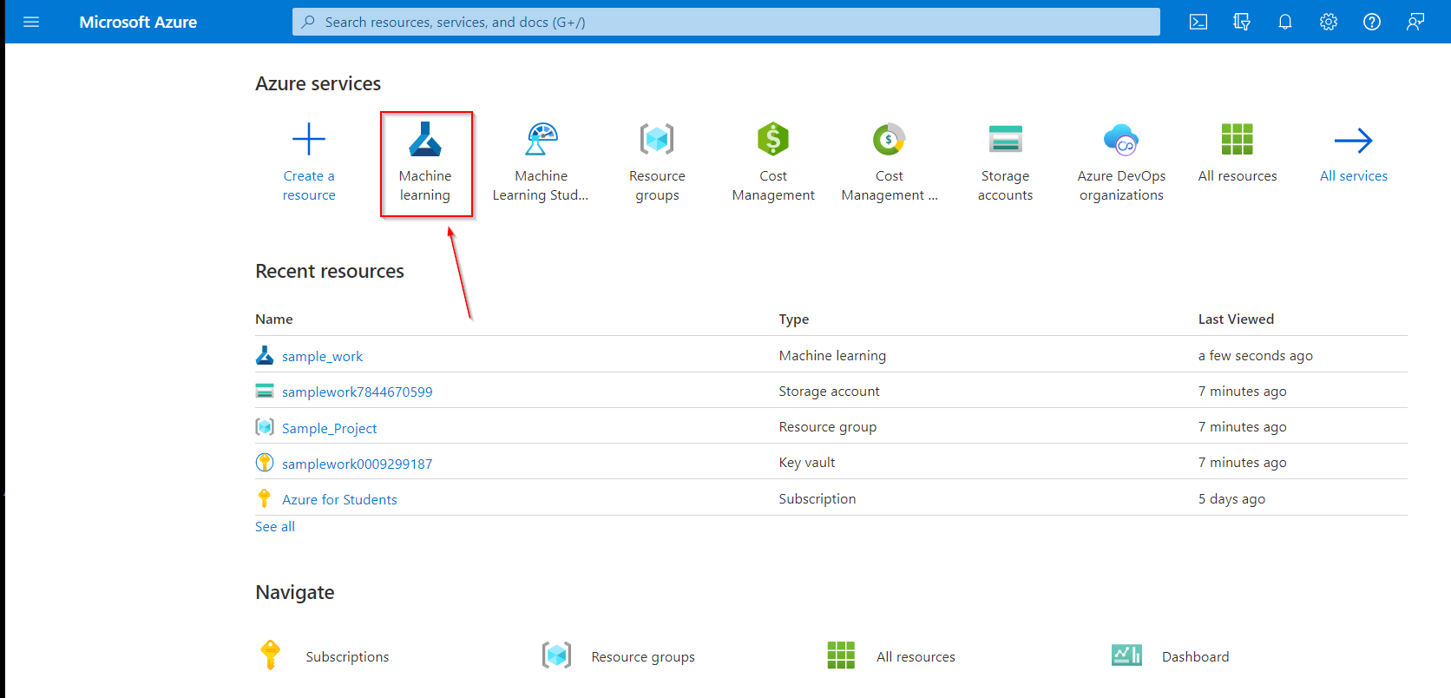

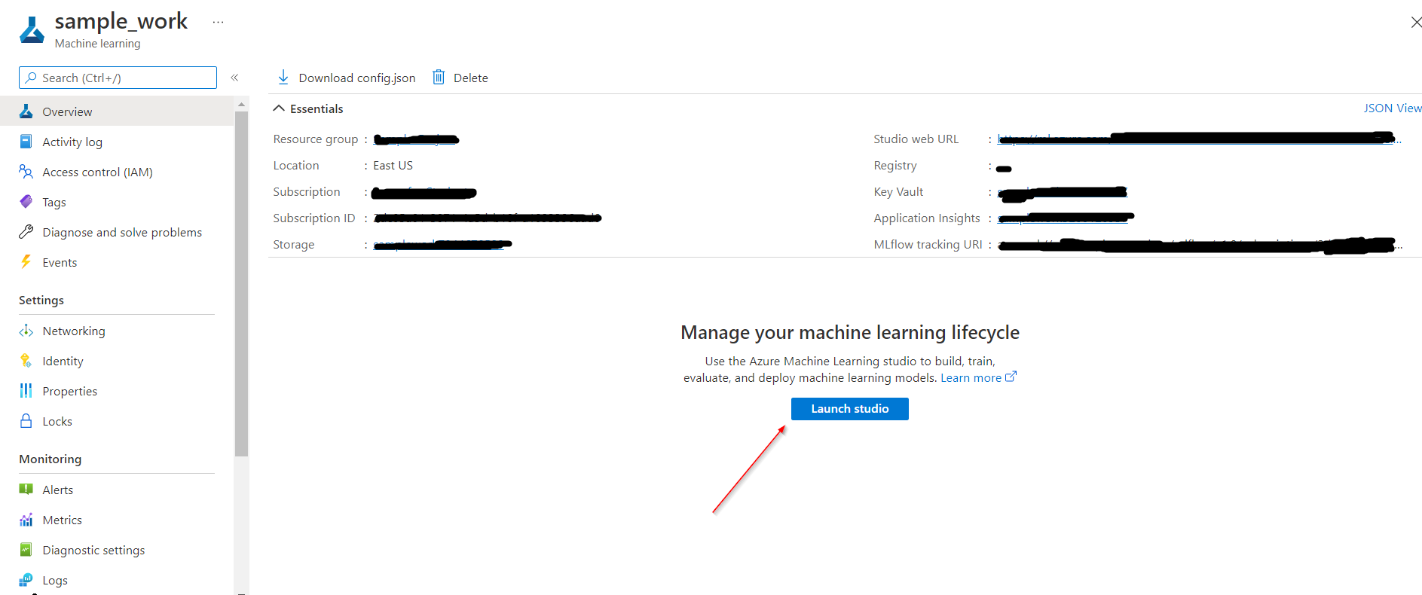

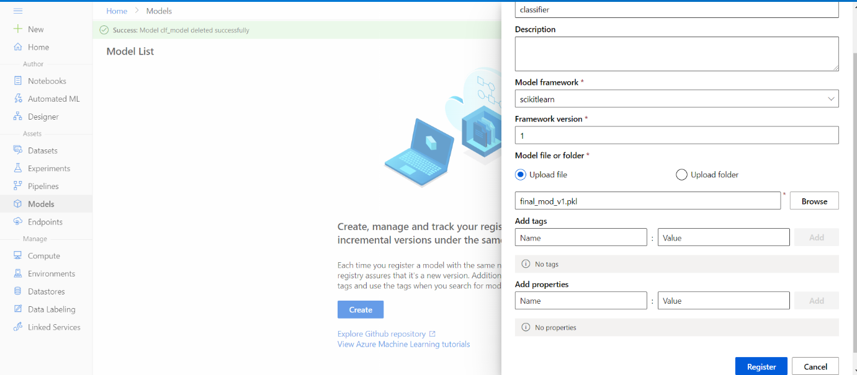

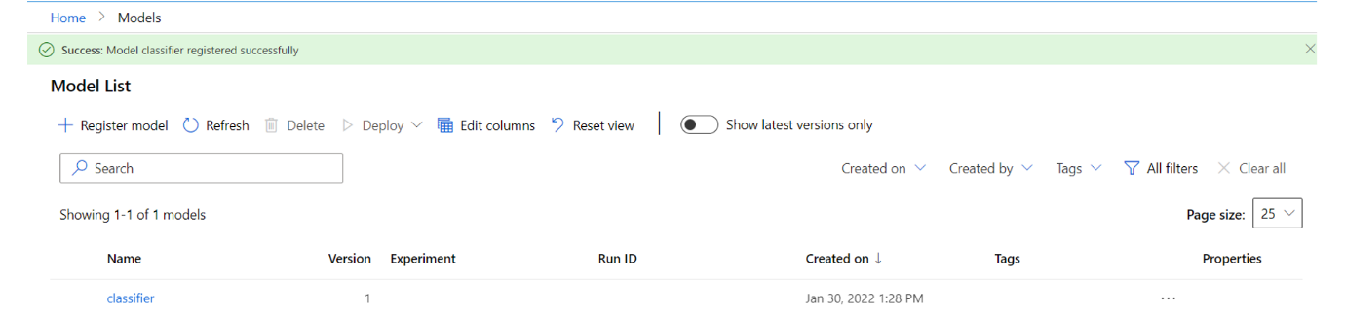

**Deploying the model**

Select the model from the model registry, click deploy and select deploy to a web service.

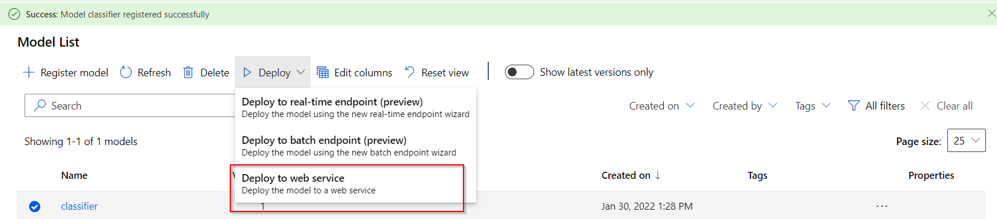

After selecting the option ” Deploy to a web service”, you will need to upload the scoring script that we created along with the YAML file containing the package dependencies.

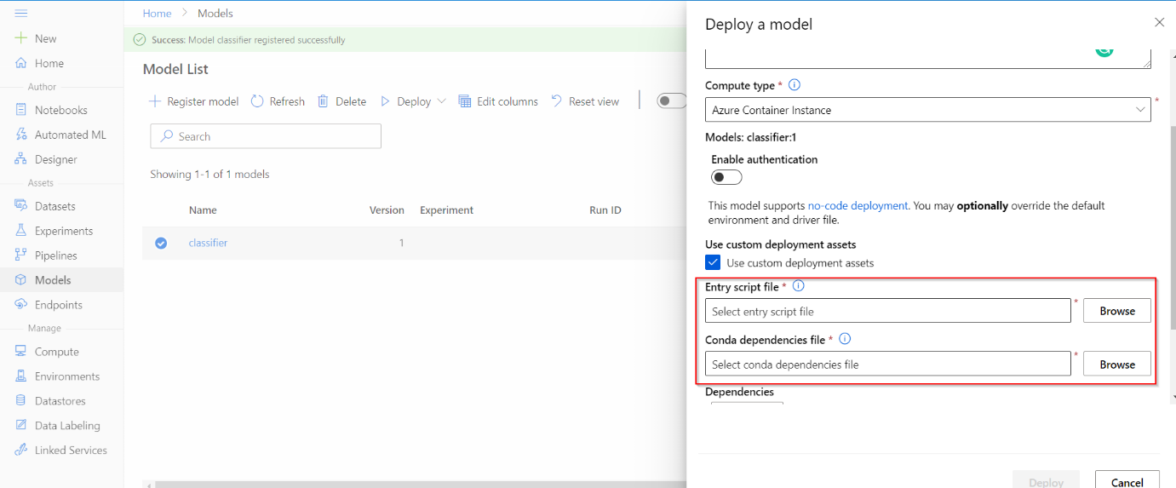

After deploying the model, go to the endpoint section. It may take approximately 6-10 minutes for the model to get deployed. If some error occurs while deploying the model, you can check the deployment logs to understand further.

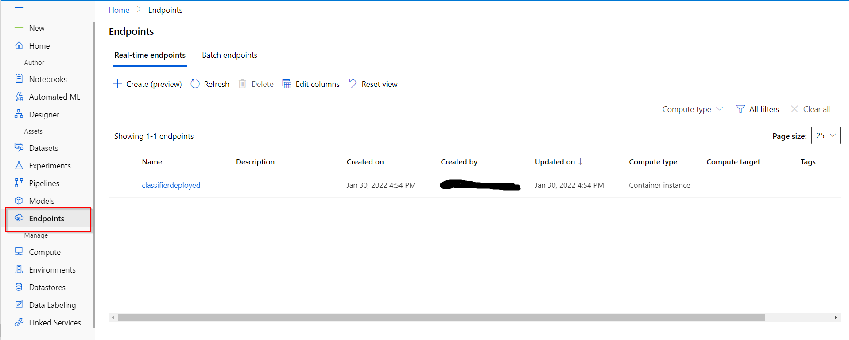

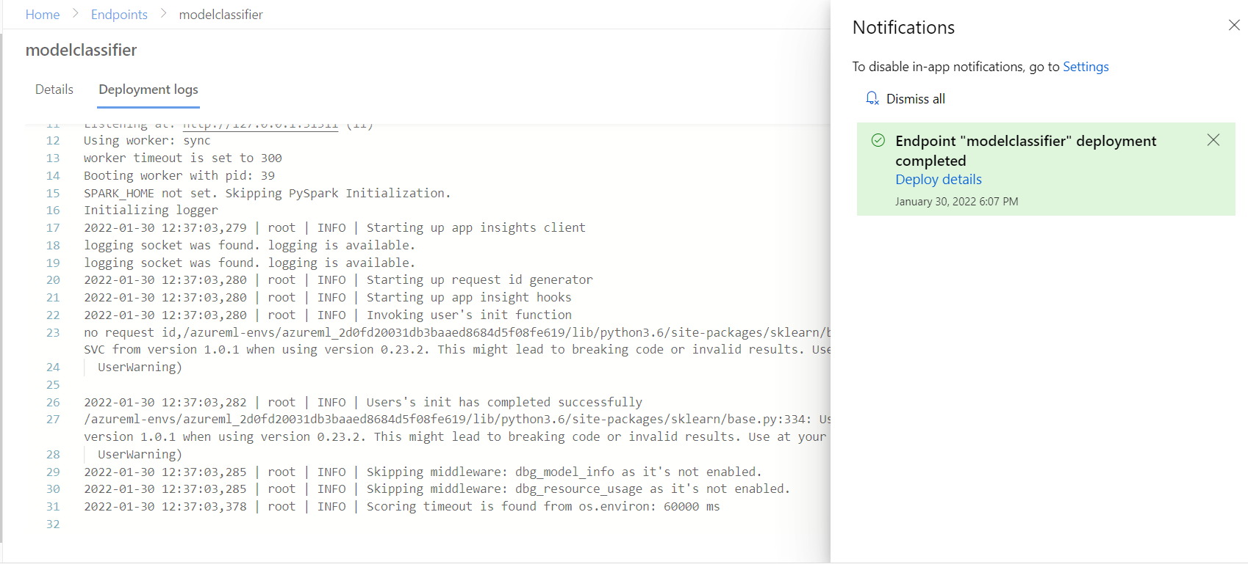

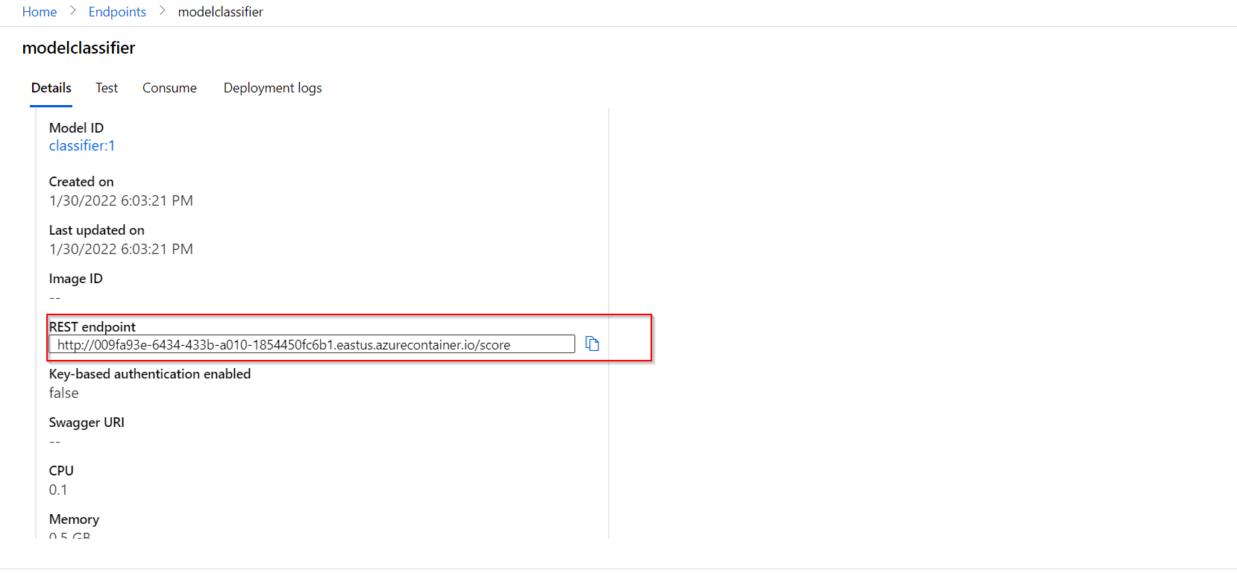

**Using the REST endpoint**

For making a prediction, let’s use the endpoint to send the input to the model that has been deployed in the cloud.

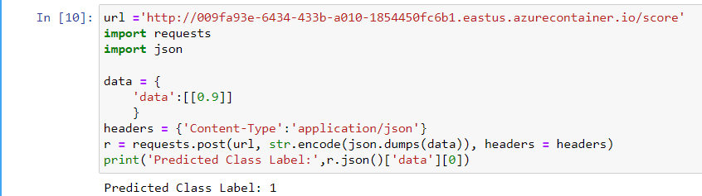

<https://pyimagesearch.com/2018/02/05/deep-learning-production-keras-redis-flask-apache/>

# Deep learning in production with Keras, Redis, Flask, and Apache

Deep learning in production with Keras, Redis, Flask, and Apache

├── helpers.py

├── jemma.png

├── keras_rest_api_app.wsgi

├── run_model_server.py

├── run_web_server.py

├── settings.py

├── simple_request.py

└── stress_test.py

[**Click here to download the source code to this post**](https://pyimagesearch.com/2018/02/05/deep-learning-production-keras-redis-flask-apache/#pyis-cta-modal)

**[](https://pyimagesearch.com/wp-content/uploads/2018/01/deep_learning_cloud_animation.gif)**

Shipping deep learning models to production is a non-trivial task.

If you don’t believe me, take a second and look at the “tech giants” such as Amazon, Google, Microsoft, etc. — nearly all of them provide some method to ship your machine learning/deep learning models to production in the cloud.

Going with a model deployment service is perfectly fine and acceptable…**but what if you wanted to own the entire process and not rely on external services?**

This type of situation is more common than you may think. Consider:

* An in-house project where you cannot move sensitive data outside your network
* A project that specifies that the entire infrastructure must reside within the company
* A government organization that needs a private cloud
* A startup that is in “stealth mode” and needs to stress test their service/application in-house

How would you go about shipping your deep learning models to production in these situations, and perhaps most importantly, **making it scalable at the same time?**

Today’s post is the final chapter in our three part series on building a deep learning model server REST API:

1. [**Part one**](https://blog.keras.io/building-a-simple-keras-deep-learning-rest-api.html) (**which was posted on the official Keras.io blog!**) is a simple Keras + deep learning REST API which is intended for single threaded use with no concurrent requests. This method is a perfect fit if this is your first time building a deep learning web server or if you’re working on a home/hobby project.
2. In [**part two**](https://pyimagesearch.com/2018/01/29/scalable-keras-deep-learning-rest-api/) we demonstrated how to leverage **Redis** along with **message queueing/message brokering** paradigms to efficiently batch process incoming inference requests (but with a small caveat on server threading that could cause problems).
3. In the final part of this series, I’ll show you how to resolve these server threading issues, further scale our method, provide benchmarks, and **demonstrate how to efficiently scale deep learning in production using Keras, Redis, Flask, and Apache.**

As the results of our stress test will demonstrate, our single GPU machine can easily handle **500 concurrent requests** (0.05 second delay in between each one) without ever breaking a sweat — ***this performance continues to scale as well.***

**To learn how to ship your own deep learning models to production using Keras, Redis, Flask, and Apache, just keep reading.**



#### Looking for the source code to this post?

[**JUMP RIGHT TO THE DOWNLOADS SECTION**](https://pyimagesearch.com/2018/02/05/deep-learning-production-keras-redis-flask-apache/#pyis-cta-modal)

## Deep learning in production with Keras, Redis, Flask, and Apache

***2020-06-16 Update:****This blog post is now TensorFlow 2+ compatible!*

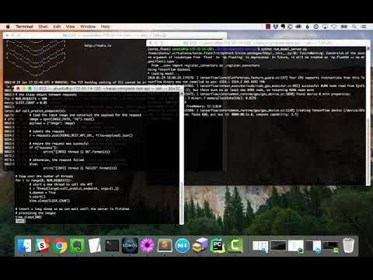

The code for this blog post is primarily based on our [**previous post**](https://pyimagesearch.com/2018/01/29/scalable-keras-deep-learning-rest-api/), but with some minor modifications — the first part of today’s guide will review these changes along with our project structure.

From there, we’ll move on to configuring our deep learning web application, including installing and configuring any packages you may need (Redis, Apache, etc.).

Finally, we’ll stress test our server and benchmark our results.

For a quick overview of our deep learning production system (including a demo) be sure to watch the video above!

### Our deep learning project structure

Our project structure is as follows:

[**→ Launch Jupyter Notebook on Google Colab**](https://pyimagesearch.com/2018/02/05/deep-learning-production-keras-redis-flask-apache/#pyis-cta-modal)

Deep learning in production with Keras, Redis, Flask, and Apache

├── helpers.py

├── jemma.png

├── keras_rest_api_app.wsgi

├── run_model_server.py

├── run_web_server.py

├── settings.py

├── simple_request.py

└── stress_test.py

Let’s review the important files:

* run_web_server.py

 contains all our Flask web server code — Apache will load this when starting our deep learning web app.

* run_model_server.py

 will:

* + Load our Keras model from disk
  + Continually poll Redis for new images to classify
  + Classify images (batch processing them for efficiency)
  + Write the inference results back to Redis so they can be returned to the client via Flask
* settings.py

 contains all Python-based settings for our deep learning productions service, such as Redis host/port information, image classification settings, image queue name, etc.

* helpers.py

 contains utility functions that both

run_web_server.py

 and

run_model_server.py

 will use (namely

base64

 encoding).

* keras_rest_api_app.wsgi

 contains our WSGI settings so we can serve the Flask app from our Apache server.

* simple_request.py

 can be used to programmatically consume the results of our deep learning API service.

* jemma.png

 is a photo of my family’s beagle. We’ll be using her as an example image when calling the REST API to validate it is indeed working.

* Finally, we’ll use

stress_test.py

 to stress our server and measure image classification throughout.

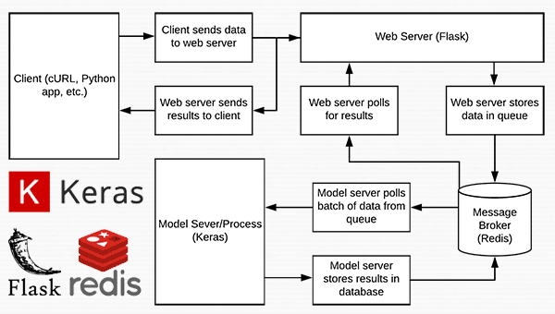

<https://www.datacamp.com/tutorial/machine-learning-models-api-python>

# Turning Machine Learning Models into APIs in Python

from flask import Flask

app = Flask(__name__)

@app.route("")

def hello():

return "Welcome to machine learning model APIs!"

if __name__ == '__main__':

app.run(debug=True)

* Flask runs on port number 5000 by default. Sometimes, the Flask server starts on this port number successfully, but when you hit the URL (that the servers return on the terminal) in a web browser or any API-client like Postman, you may not get the output. Consider the following situation:

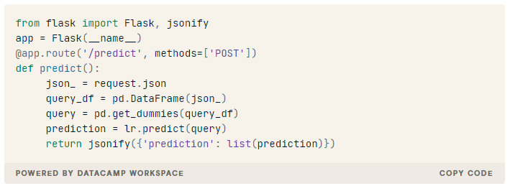

<https://christophergs.com/machine%20learning/2019/03/17/how-to-deploy-machine-learning-models/>

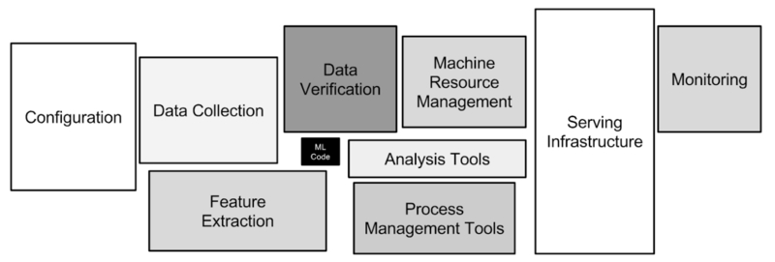

Four potential ML system architecture approaches:

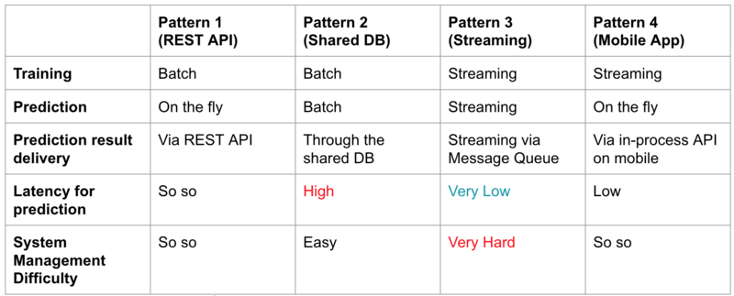

An example system diagram for a pattern 1 system:

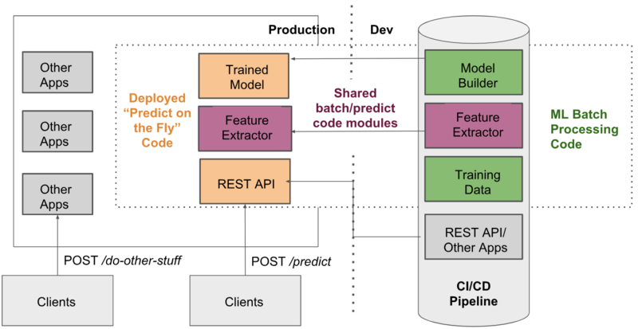

### 6. Testing

If you are not a software engineer, you may view tests as a “nice to have”. This is inaccurate. They are crucial. ‘Nuff said.

However, vanilla unit/integration/acceptance tests (follow this [good reference](https://landing.google.com/sre/sre-book/chapters/testing-reliability/) to understand the different types of tests) won’t cut it for machine learning systems. In addition to those tests, it’s worth expanding the toolkit to include:

* **Differential Tests**: Where you compare the average/per row predictions given by a new model vs. the predictions given by the old model on a standard test data set. You need to tweak the sensitivity of these tests depending on the model use case. These tests can be vital for detecting otherwise healthy-seeming models, for example where an outdated dataset has been used in training, or a feature has been accidentally removed from the [feature selection](https://www.trainindatablog.com/feature-selection-for-machine-learning-comprehensive-overview/) code. These sorts of ML-specific issues would not cause traditional tests to fail. What’s worse, without effective differential tests, you might have no idea about this mistake until long after the damage is done. You don’t want to have to explain this sort of thing to a regulator.
* **Benchmark Tests**: These tests compare the time taken to either train or serve predictions from your model from one version to the next. They prevent you from introducing inefficient code additions to your ML applications. Again, this is something that is hard to catch with traditional tests (although some static code analysis tools will help). If you’re working with Python, the [pytest-benchmark](https://github.com/ionelmc/pytest-benchmark) library is worth checking out.
* **Load/Stress tests**: These are not really ML-specific, but given the unusually large CPU/Memory demands of some ML applications, these sorts of tests are particularly worth performing.

All of the tests above are much easier with containerized applications, as it makes spinning up a realistic production stack trivial.

An example set of components involved in the whole deployment lifecycle:

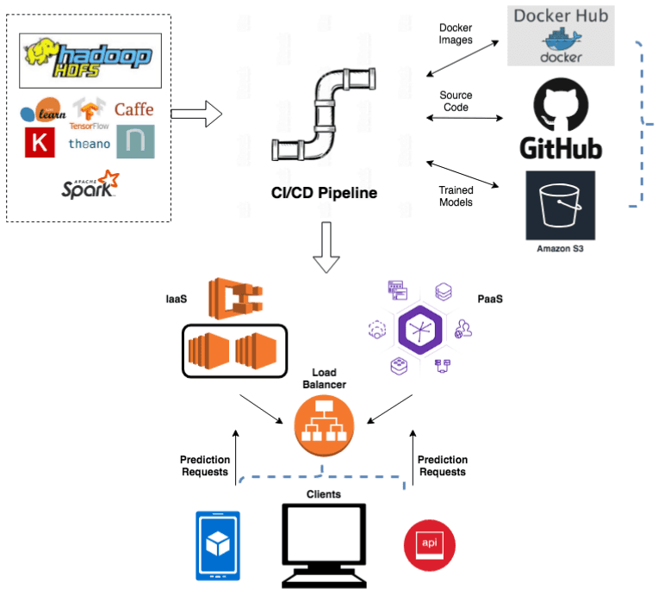

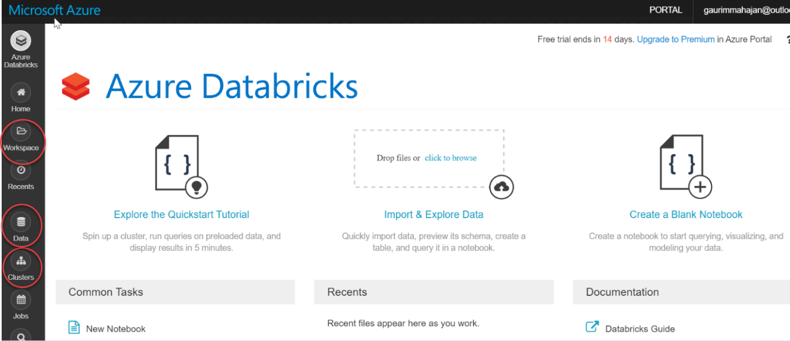

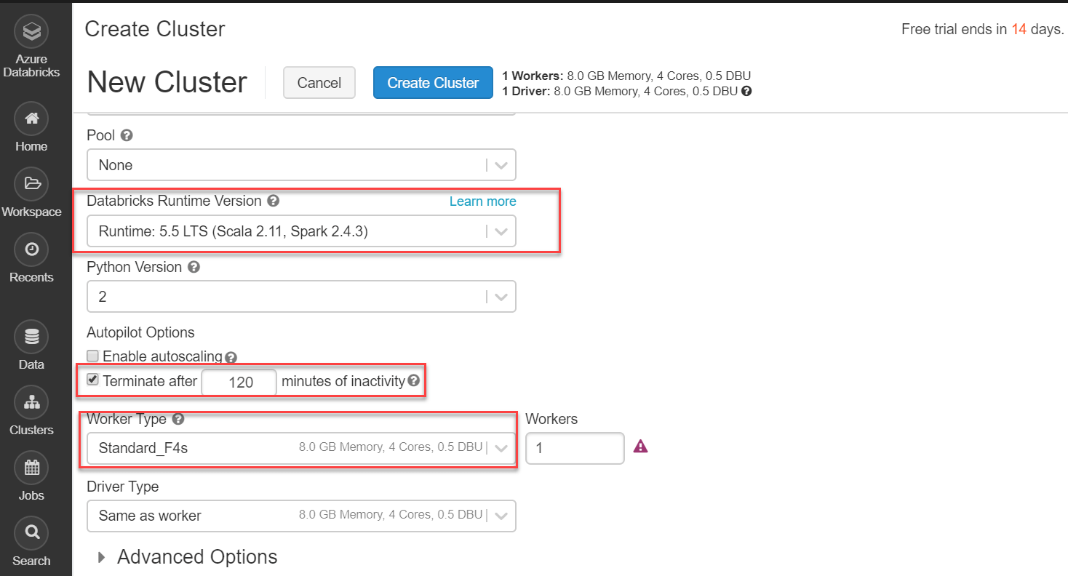

BIG DATA

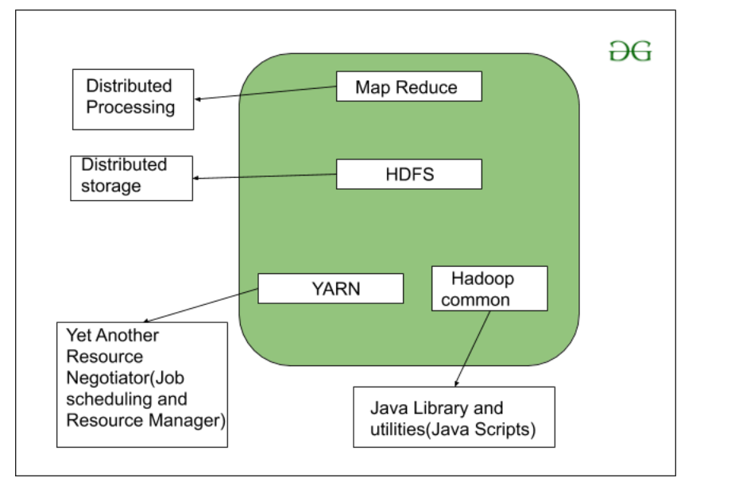

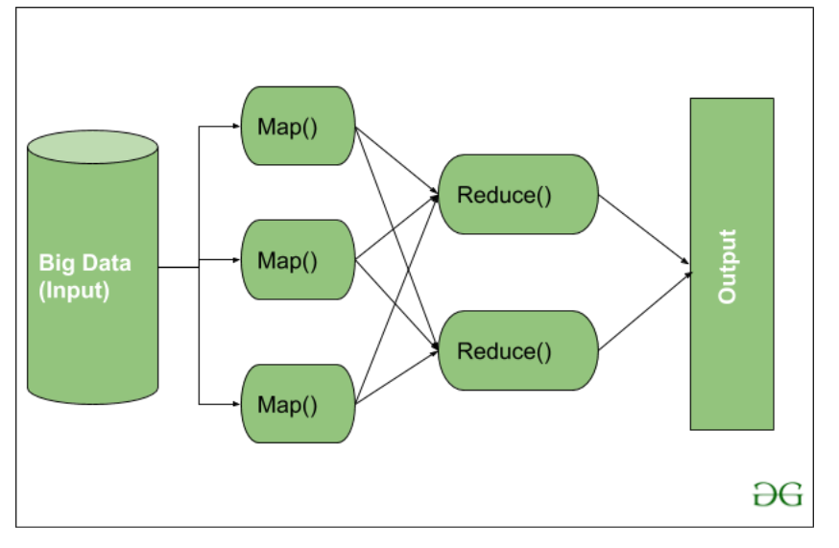

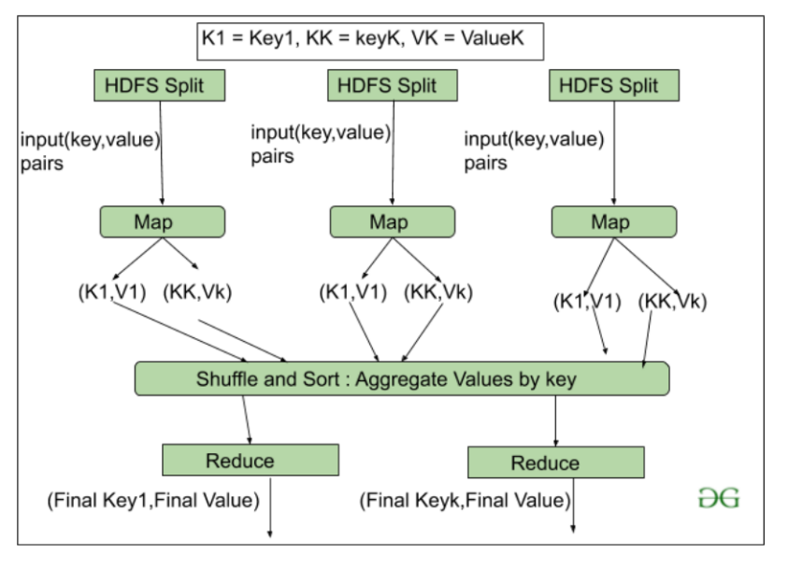

HDFS in Hadoop provides Fault-tolerance and High availability to the storage layer and the other devices present in that Hadoop cluster. Data storage Nodes in HDFS.

* NameNode(Master)
* DataNode(Slave)
* **NameNode:**NameNode works as a Master in a Hadoop cluster that guides the Datanode(Slaves). Namenode is mainly used for storing the Metadata i.e. the data about the data. Meta Data can be the transaction logs that keep track of the user’s activity in a Hadoop cluster.
* Meta Data can also be the name of the file, size, and the information about the location(Block number, Block ids) of Datanode that Namenode stores to find the closest DataNode for Faster Communication. Namenode instructs the DataNodes with the operation like delete, create, Replicate, etc.
* **DataNode:** DataNodes works as a Slave DataNodes are mainly utilized for storing the data in a Hadoop cluster, the number of DataNodes can be from 1 to 500 or even more than that. The more number of DataNode, the Hadoop cluster will be able to store more data. So it is advised that the DataNode should have High storing capacity to store a large number of file blocks.

**Replication In HDFS** Replication ensures the availability of the data. Replication is making a copy of something and the number of times you make a copy of that particular thing can be expressed as it’s Replication Factor. As we have seen in File blocks that the HDFS stores the data in the form of various blocks at the same time Hadoop is also configured to make a copy of those file blocks.

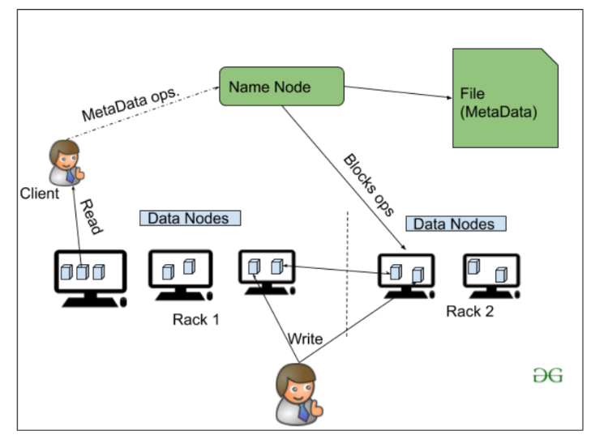

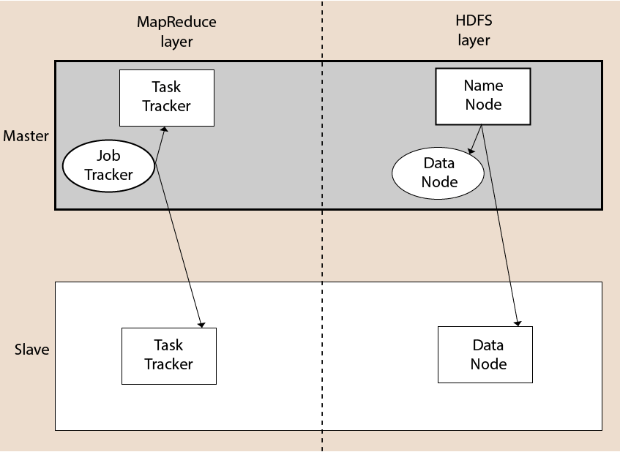

## Apache Spark Advantages

* Spark is a general-purpose, **in-memory**, fault-tolerant, **distributed processing** engine that allows you to process data efficiently in a distributed fashion.
* Applications running on Spark are **100x** faster than traditional systems.
* You will get great benefits using Spark for data ingestion pipelines.
* Using Spark we can process data from Hadoop **HDFS**, **AWS S3**, **Databricks DBFS**, **Azure Blob Storage,** and many file systems.
* Spark also is used to process real-time data using **Streaming** and **Kafka**.
* Using Spark Streaming you can also stream files from the file system and also stream from the socket.
* Spark natively has **machine learning** and **graph libraries**.

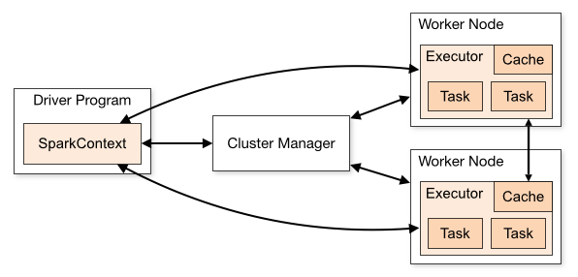

### SparkSession

[SparkSession](https://sparkbyexamples.com/spark/sparksession-explained-with-examples/) introduced in version 2.0, It is an entry point to underlying Spark functionality in order to programmatically use Spark RDD, DataFrame and Dataset. It’s object *spark* is default available in spark-shell.

Creating a SparkSession instance would be the first statement you would write to program with [RDD](https://sparkbyexamples.com/spark-rdd-tutorial/), [DataFrame](https://sparkbyexamples.com/spark/different-ways-to-create-a-spark-dataframe/) and Dataset. SparkSession will be created using SparkSession.builder() builder pattern.

import org.apache.spark.sql.SparkSession

val spark:SparkSession = SparkSession.builder()

.master("local[1]")

.appName("SparkByExamples.com")

.getOrCreate()

import org.apache.spark.SparkContext

import org.apache.spark.SparkContext._

import org.apache.spark._

object SparkWordCount {

def main(args: Array[String]) {

val sc = new SparkContext( "local", "Word Count", "/usr/local/spark", Nil, Map(), Map())

/* local = master URL; Word Count = application name; */

/* /usr/local/spark = Spark Home; Nil = jars; Map = environment */

/* Map = variables to work nodes */

/*creating an inputRDD to read text file (in.txt) through Spark context*/

val input = sc.textFile("in.txt")

/* Transform the inputRDD into countRDD */

val count = input.flatMap(line ⇒ line.split(" "))

.map(word ⇒ (word, 1))

.reduceByKey(_ + _)

/* saveAsTextFile method is an action that effects on the RDD */

count.saveAsTextFile("outfile")

System.out.println("OK");

}

}

scala> val counts = inputfile.flatMap(line => line.split(" ")).map(word => (word, 1)).reduceByKey(_+_);

The Spark follows the master-slave architecture. Its cluster consists of a single master and multiple slaves.

The Spark architecture depends upon two abstractions:

* Resilient Distributed Dataset (RDD)
* Directed Acyclic Graph (DAG)

## **Resilient Distributed Datasets (RDD)**

The Resilient Distributed Datasets are the group of data items that can be stored in-memory on worker nodes. Here,

* Resilient: Restore the data on failure.
* Distributed: Data is distributed among different nodes.
* Dataset: Group of data.

## **Directed Acyclic Graph (DAG)**

Directed Acyclic Graph is a finite direct graph that performs a sequence of computations on data. Each node is an RDD partition, and the edge is a transformation on top of data. Here, the graph refers the navigation whereas directed and acyclic refers to how it is done.

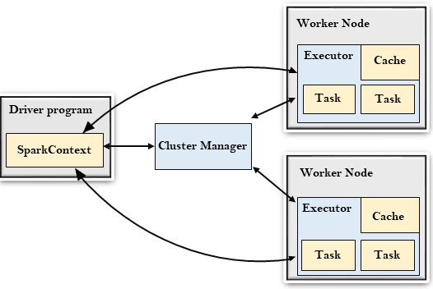

## **Driver Program**

The Driver Program is a process that runs the main() function of the application and creates the **SparkContext** object. The purpose of **SparkContext** is to coordinate the spark applications, running as independent sets of processes on a cluster.

To run on a cluster, the **SparkContext** connects to a different type of cluster managers and then perform the following tasks: -

* It acquires executors on nodes in the cluster.
* Then, it sends your application code to the executors. Here, the application code can be defined by JAR or Python files passed to the SparkContext.
* At last, the SparkContext sends tasks to the executors to run.

## **Cluster Manager**

* The role of the cluster manager is to allocate resources across applications. The Spark is capable enough of running on a large number of clusters.
* It consists of various types of cluster managers such as Hadoop YARN, Apache Mesos and Standalone Scheduler.
* Here, the Standalone Scheduler is a standalone spark cluster manager that facilitates to install Spark on an empty set of machines.

### Worker Node

* The worker node is a slave node
* Its role is to run the application code in the cluster.

### Executor

* An executor is a process launched for an application on a worker node.
* It runs tasks and keeps data in memory or disk storage across them.
* It read and write data to the external sources.
* Every application contains its executor.

### Task

* A unit of work that will be sent to one executor.

## **MLOps Tutorial for Beginners**

<https://www.projectpro.io/data-science-in-python-tutorial/mlops-python-tutorial-for-beginners>

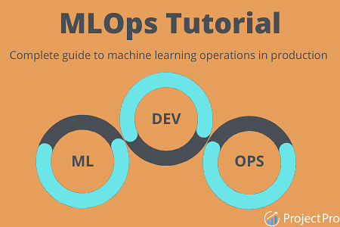

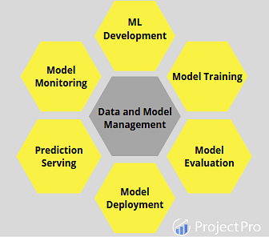

1. ML Development: This is the basic step that involves creating a complete pipeline beginning from data processing to model training and evaluation codes.
2. Model Training: Once the setup is ready, the next logical step is to train the model. Here, continuous training functionality is also needed to adapt to new data or address specific changes.
3. Model Evaluation: Performing inference over the trained model and checking the accuracy/correctness of the output results.
4. Model Deployment: When the proof of concept stage is accomplished, the other part is to deploy the model according to the industry requirements to face the real-life data.
5. Prediction Serving: After deployment, the model is now ready to serve predictions over the incoming data.
6. Model Monitoring: Over time, problems such as concept drift can make the results inaccurate hence continuous monitoring of the model is essential to ensure proper functioning.
7. Data and Model Management: It is a part of the central system that manages the data and models. It includes maintaining storage, keeping track of different versions, ease of accessibility, security, and configuration across various cross-functional teams.

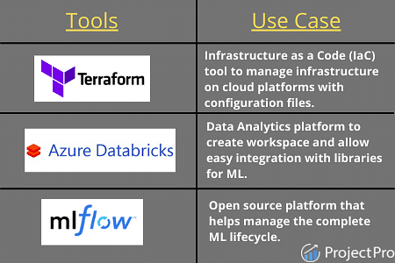

### MLOps Tutorial Step 1 - ML Development

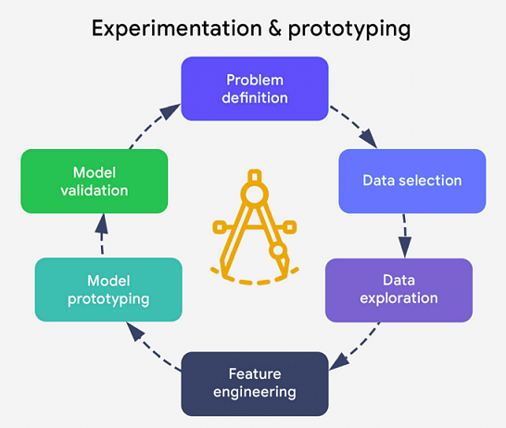

### MLOps Tutorial Step 2- Model Building and Training

### 

### 

### MLOps Tutorial Step 3 - Training Operationalisation

### 

### MLOps Tutorial Step 4 - Model Versioning

### 

### MLOps Tutorial Step 5 - Model Registry

### 

### MLOps Tutorial Step 6 - Model Governance

### 

Key features of model governance are:

1. Ability to store the model artifacts and add/update them.
2. One can decide upon a winner model out of the different versions based on the available evaluation metrics. Some examples of metrics are accuracy, precision, recall, or F-score.
3. Authorized people can keep a check on the stored artifacts and version progress. First, the models will be reviewed then later approved or rejected based on the performance. This ensures protection from risks related to security, privacy, or financial aspects.
4. Once finalized the model can be processed to move to deployment. In case of failures, it can roll back to the previous stage.
5. Model performance metrics can be analyzed and visualized to create a performance report. This warrants a good quality model for production.

### MLOps Tutorial Step 7 - Model Deployment

### 

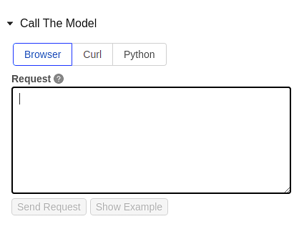

### MLOps Tutorial Step 8 - Prediction Serving

Key features of prediction serving are:

1. Test the performance on target infrastructure with actual use case data.
2. Store the requests and responses in the serving logs to keep track of performance and utilize them for model analysis and monitoring.

### MLOps Tutorial Step 9 - Model Monitoring

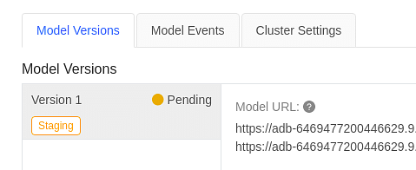

<https://www.datacamp.com/tutorial/tutorial-machine-learning-pipelines-mlops-deployment>

# Machine Learning, Pipelines, Deployment and MLOps Tutorial

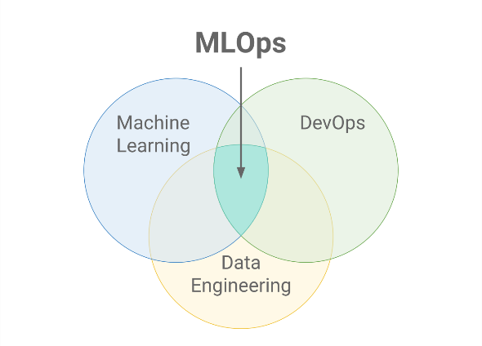

CI/CD is a practice derived from DevOps and it refers to an ongoing process of recognizing issues, reassessing, and updating the machine learning models automatically. The main concepts attributed to CI/CD are **continuous integration, continuous delivery, and continuous deployment**. It automates the machine learning pipeline (building, testing and deploying) and greatly reduces the need for data scientists to intervene in the process manually, making it efficient, fast, and less prone to human error.

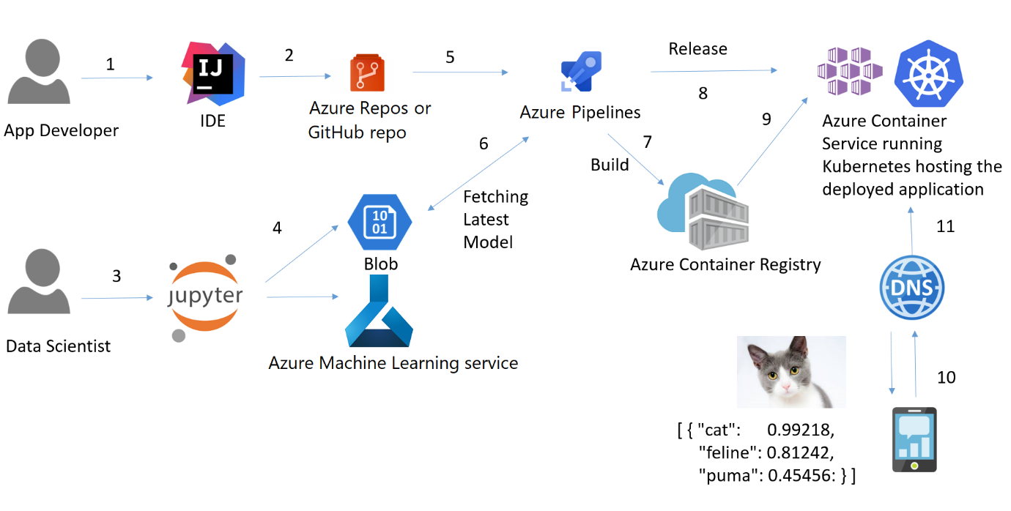

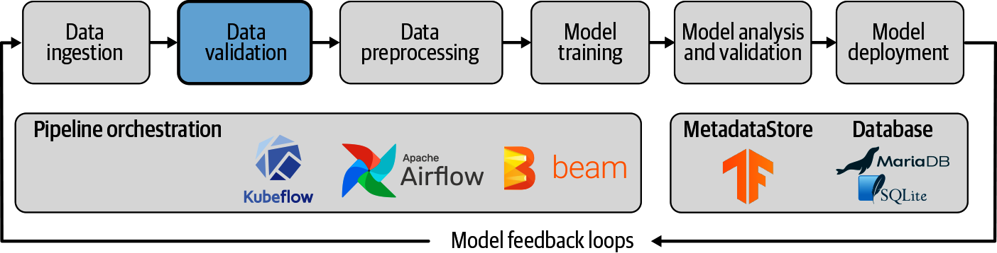

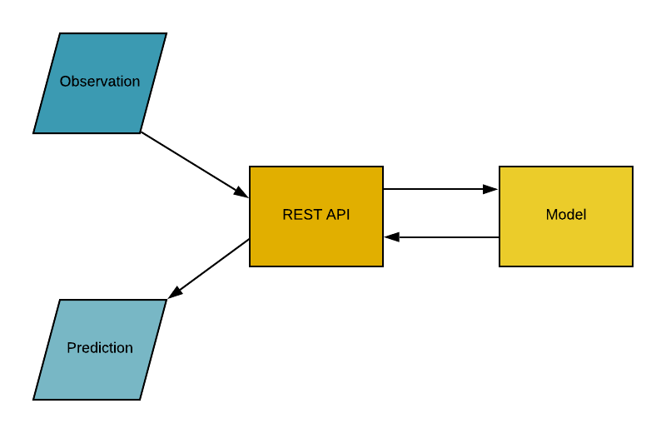

### Kubernetes

Developed by Google back in 2014, Kubernetes is a powerful, open-source system for managing containerized applications. In simple words, Kubernetes is a system for running and coordinating containerized applications across a cluster of machines. It is a platform designed to completely manage the life cycle of containerized applications.

#### Why do you need Kubernetes if you have Docker?

Imagine a scenario where you have to run multiple Docker containers, on multiple machines, to support an enterprise-level ML application with varied workloads day and night. As simple as it may sound, it is a lot of work to do manually.

You need to start the right containers at the right time, figure out how they can talk to each other, handle storage considerations, and deal with failed containers or hardware. This is the problem Kubernetes is solving, by allowing large numbers of containers to work together in harmony, and reducing the operational burden.